HOW PACKAGE DEISGN PLAYS AN IMPORTANT ROLE IN BRAND-BUILDING

Jingsi Li

University of Nebraska Lincoln
February 4

Approved by: ________________________
Date: _______________________________

TABLE OF CONTENTS
1：Introduction
1): Research Statement................................................................................................................04 2): Areas of Interest.....................................................................................................................04
3): Personal Motivation...............................................................................................................05
4): Purpose of research...............................................................................................................05
5): Significance............................................................................................................................06

2：Literature Review
1): Introduction to literature review.............................................................................................07
2): Color Psychology.....................................................................................................................07
3): Gender, Design, and Marketing................................................................................................08
4): Eating Disorders and Eating Behavior....................................................................................08
5): Conclusion...............................................................................................................................09
3:Methods
1):Introduction..............................................................................................................................10
2):Research Design.......................................................................................................................10
3): Data Collection and Analysis..................................................................................................11
4): Limitation................................................................................................................................11

4:timeline
Table#1.........................................................................................................................................12

5:bibliography
Attachment...................................................................................................................................13
Table#2.........................................................................................................................................13
Table#3.........................................................................................................................................14
Table#4.........................................................................................................................................15
Reference......................................................................................................................................24

1：Introduction

Research Statement

More and more people like enjoy a pastry or desert after their meal and they also will buy some pastry as gift for their family and friends. Also, China has a long history of pastry but people in other country are not familiar with it. Although, Many people love traditional Chinese pastry so much after they tried it. However, what they did not know is that there are lots of moving stories about this pastry. I really want more people to know that. So I decided to create my own brand for four traditional pastries including sweet heart pastry, sweet green dumpling，pineapple pastry and osmanthus cake. I will design a logo and poster, package and business card and gift card for it. Packaging-design is the most important part of my project.

Areas of Interest
Packing-design is my favourite part in graphic design because it is the most creative part. Also, the designer should pay more attention about user experience and practicality. They also need to think about material and marketing. The goal of a good package is not just be a container but also be a collection or be rectilization.

Personal Motivation
I am a big fan of sweet food and backery. I was growing up in China with my grandparents. They always told me many interesting or touching stories from ancient. The most frequently stories I heard about are about food. Food plays an important role in our life. Food can not only fill up our stomach, but it also conveys the love and best wishes between people and people. I am good at bakery so that I always baked some traditional Chinese pastry for my friends to show my love or gratitude for them. For those reason, I think a brand of pastry should be designed, which can be used to convey those feeling as a gift. The brand will not only sell pastry but also sell stories and feelings.

Purpose of Research
This research is talking about how packaging-design plays an important role in brand-building. My research is including: branding and why packaging-design is important and what can make a package be a good packing-design, how to do a packaging-design, and materials and techniques. I will focus more on the part of package design.

Significance
Chinese traditional pastry has a long history. It has many varieties and tastes with unique flavor, but most of package of it in market is simple without any aesthetic value and not suitable for storage and gift. It just a food container. I think the package of a pastry should be delicately. Also, the pastries that are seen in the market are mostly packed with complex packages. The "Chinese wind" is filled with a variety of auspicious patterns, which neither inherit the traditional Chinese culture, but also divorced from the modern aesthetic. I will try my best to create a pastry brand, which with good taste and can be used as gift to express the feeling between people.
2：Literature Review
Introduction to literature review
This is an important part of my research, which the theoretical foundation for my study. I read a lot of article and journals in school’s library and do a lot of research about branding, marketing and package design. Food packaging from the beginning, has always been the main part of packaging design. Food is liable to decay and lose its nutritional value and commodity value so that food must be properly packaged to store. With the increasing level of science and technology and people's consumption level, the requirement for food packaging design is increasing. The rapid development and variety of food packaging not only enrich people's life, but also gradually change people's way of life. The research includs two parts: (1)The relationship with packaging design and buying behavior of consumers. (2): packaing elements: logo, size, color, graphic, text, texture, and material.

Gender, Design, and Marketing
Eating Disorders.
Conclusion

3.Methods
Introduction
I used the survey as my research methods. The questionnaire is an essential method of the information and data collected on the society, it can be used to help me understand the perference of consumers. By analyzing the collected data and information, I can know what is my audience really want. This has played an important role in the development of my research. I also do many research from some famous brand.

Research Design
My survey is mainly about people’s cognition about Chinese pastry and style because I want to know how many people really know what is Chinese pastry and their attitude toward it. At first, I asked people to write down their favourite bakery brand so that I can do research about it to know what they do to attrack people. Also, I think that knowing what factor plays the most important role to attract people is important. At the same time, I designed some question to collect people opion abour logo, color, shape and material of their perference. I asked them to descibe what is the Chinese style in their mind. I believed that depending on the result from this survey, the packaging design will be more easy to be accepted by consumers.

Data Collection and Analysis

I got lots of helpful responses from this survey. At first, Hostess and Panera is the most favourite bakery brand from my survey. I did some research about those two brands. I found that convenience is the advantage of this brand because it is avaliable in every market and shop. At the same time, the flavor of Hostess is in the American taste. Meanwhile, Oragnic and healthy is the symbol of Panera because the most of American care about their health. In this survey, we can tell flavor and nutrition are two essential parts which people care about. They hope to see logo and package in traditional Chinese style. They thought that red and goden can represent China. For packaging design, 61% of responsers prefer paper and cloth than other material because those material can be recycle, which is more enviorment friendly. However, 26% of them still hope plastics can be applied to the inner package for freshness and food safety. 51.22% of audiences like the clean and simple style while 19.27% of them like to see oragnic plant and creature pattern on the package.
I got some important informantion from this survey. The first one is that people hope this package is recyclable and easy to open but the inner part is air sealed for freshness. Secondly, showing of flavor and tradition should be clear visible. Thirdly, some elements like Chinese letter and symbol, transparent style is what people hope to see on the product.

Limitation
There is some limitation of my questionnaire. Firstly, 65.85% of my response is from female. The peoblem is same as 43.90% of my response is from people who are older than 60 years old. People who in this age usually consume pastry less than young people and it is more difficult for them to accept new things.

4.Timeline
Table 1: timeline
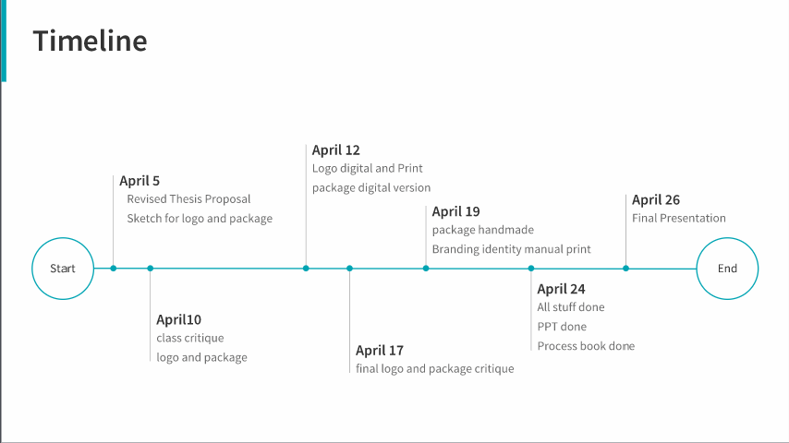

5.Bibliography
Attachment
Table 2: Questionnaire Page#1
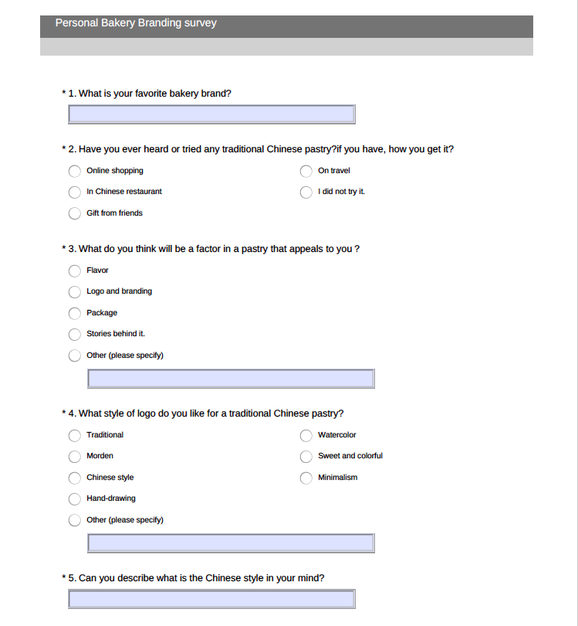

Table 3: Questionnaire Page#2
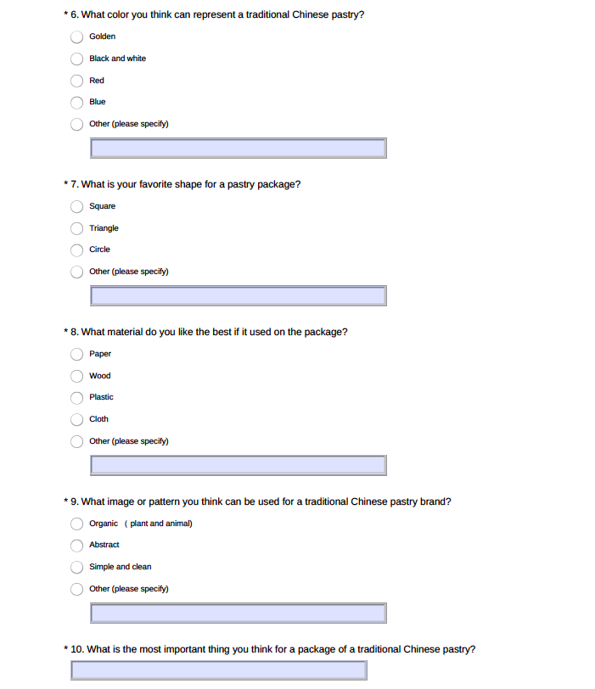

Table 4: Data
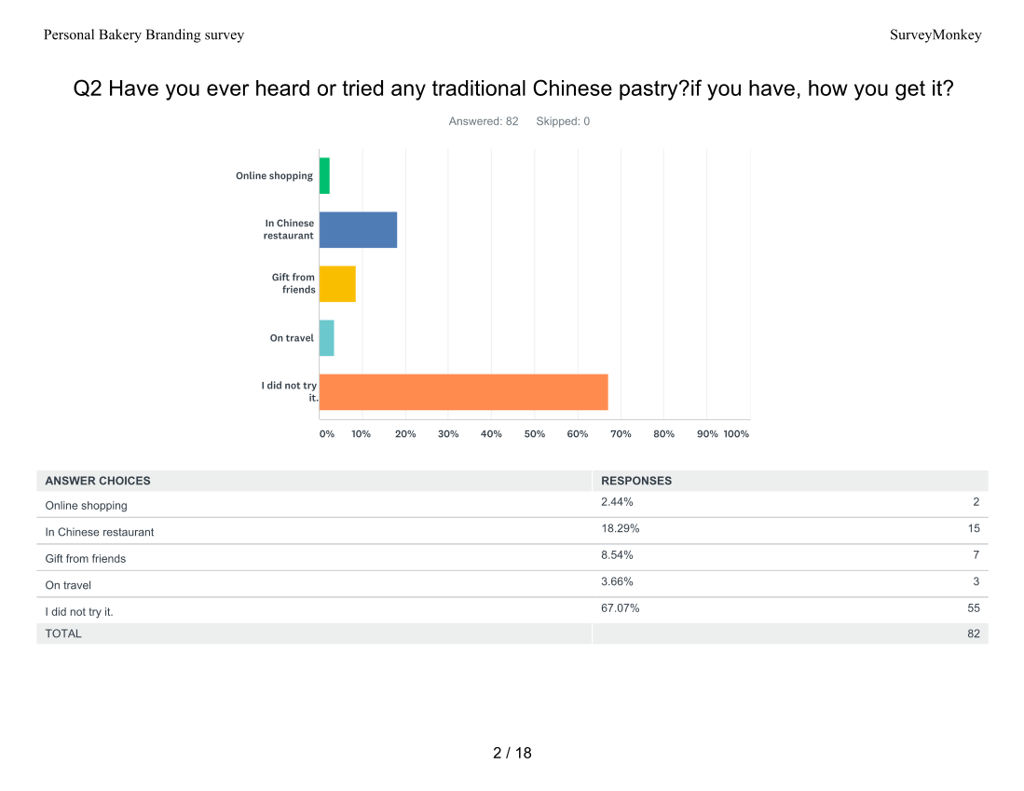

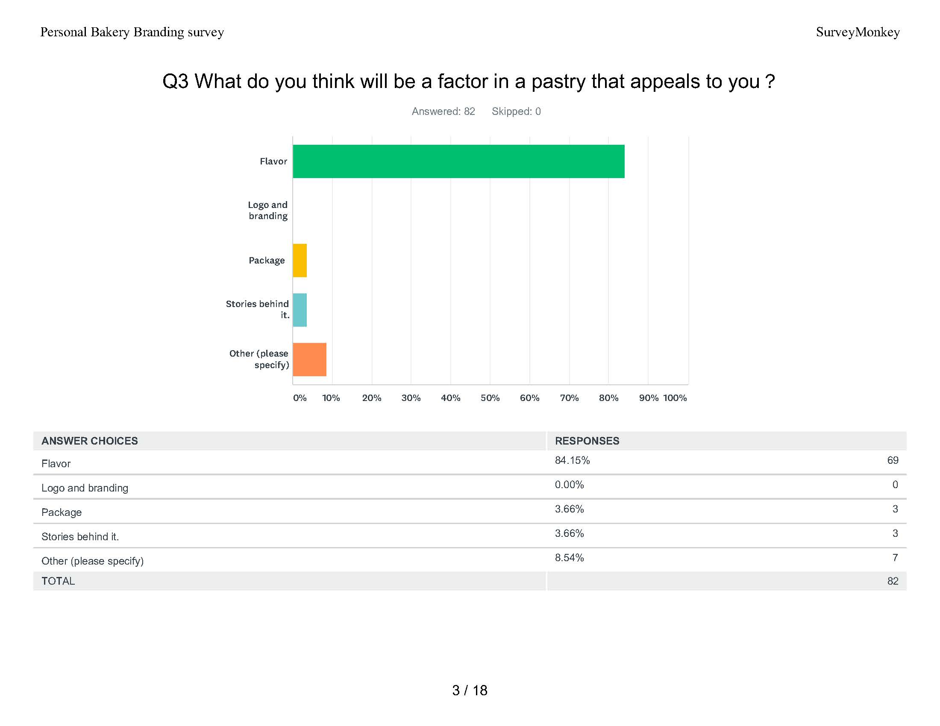

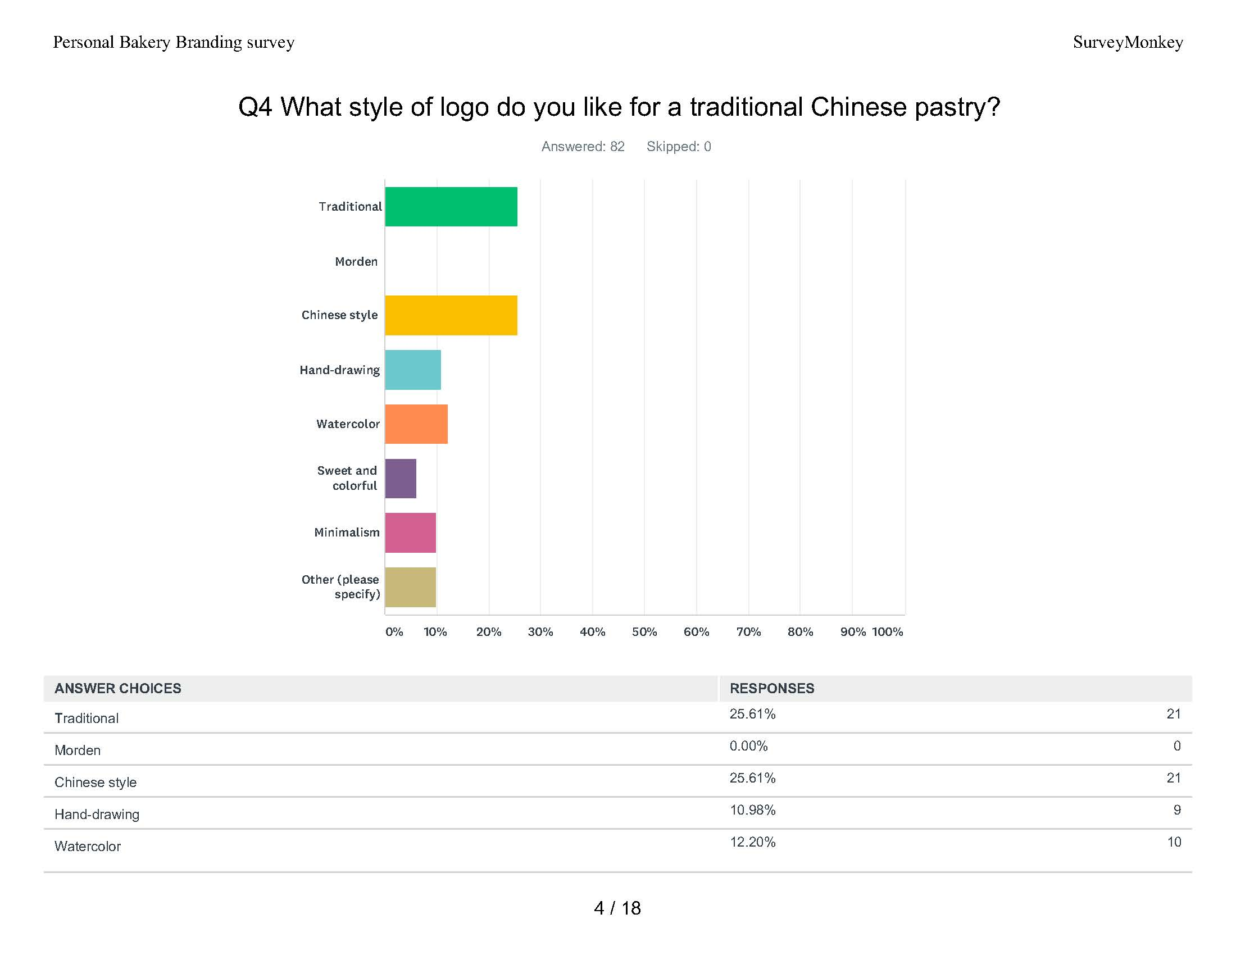

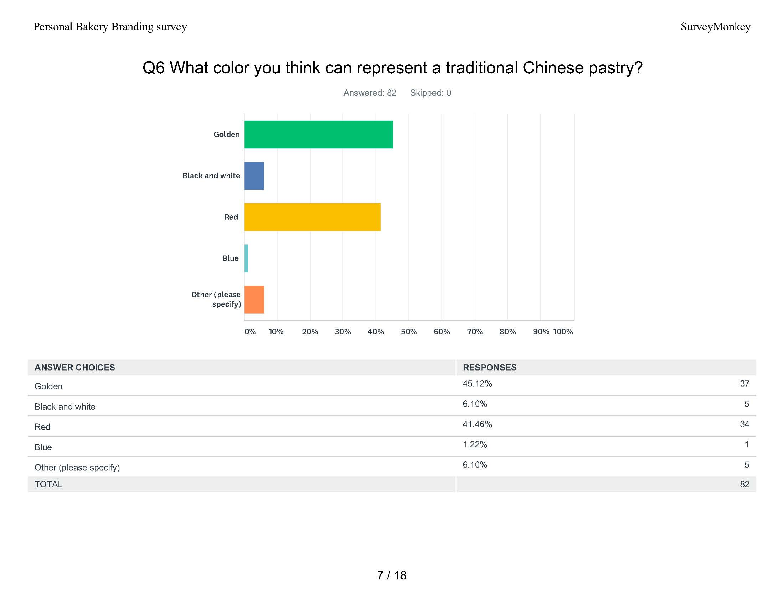

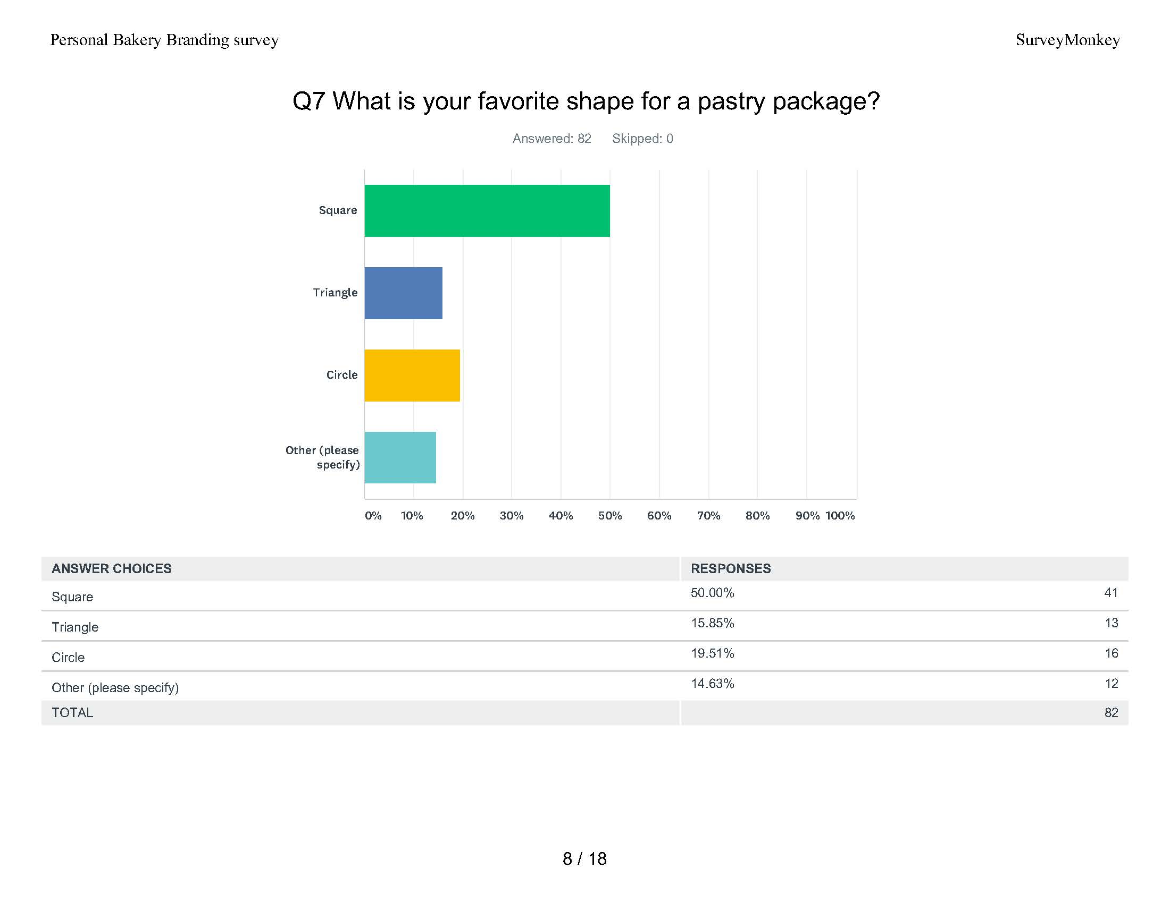

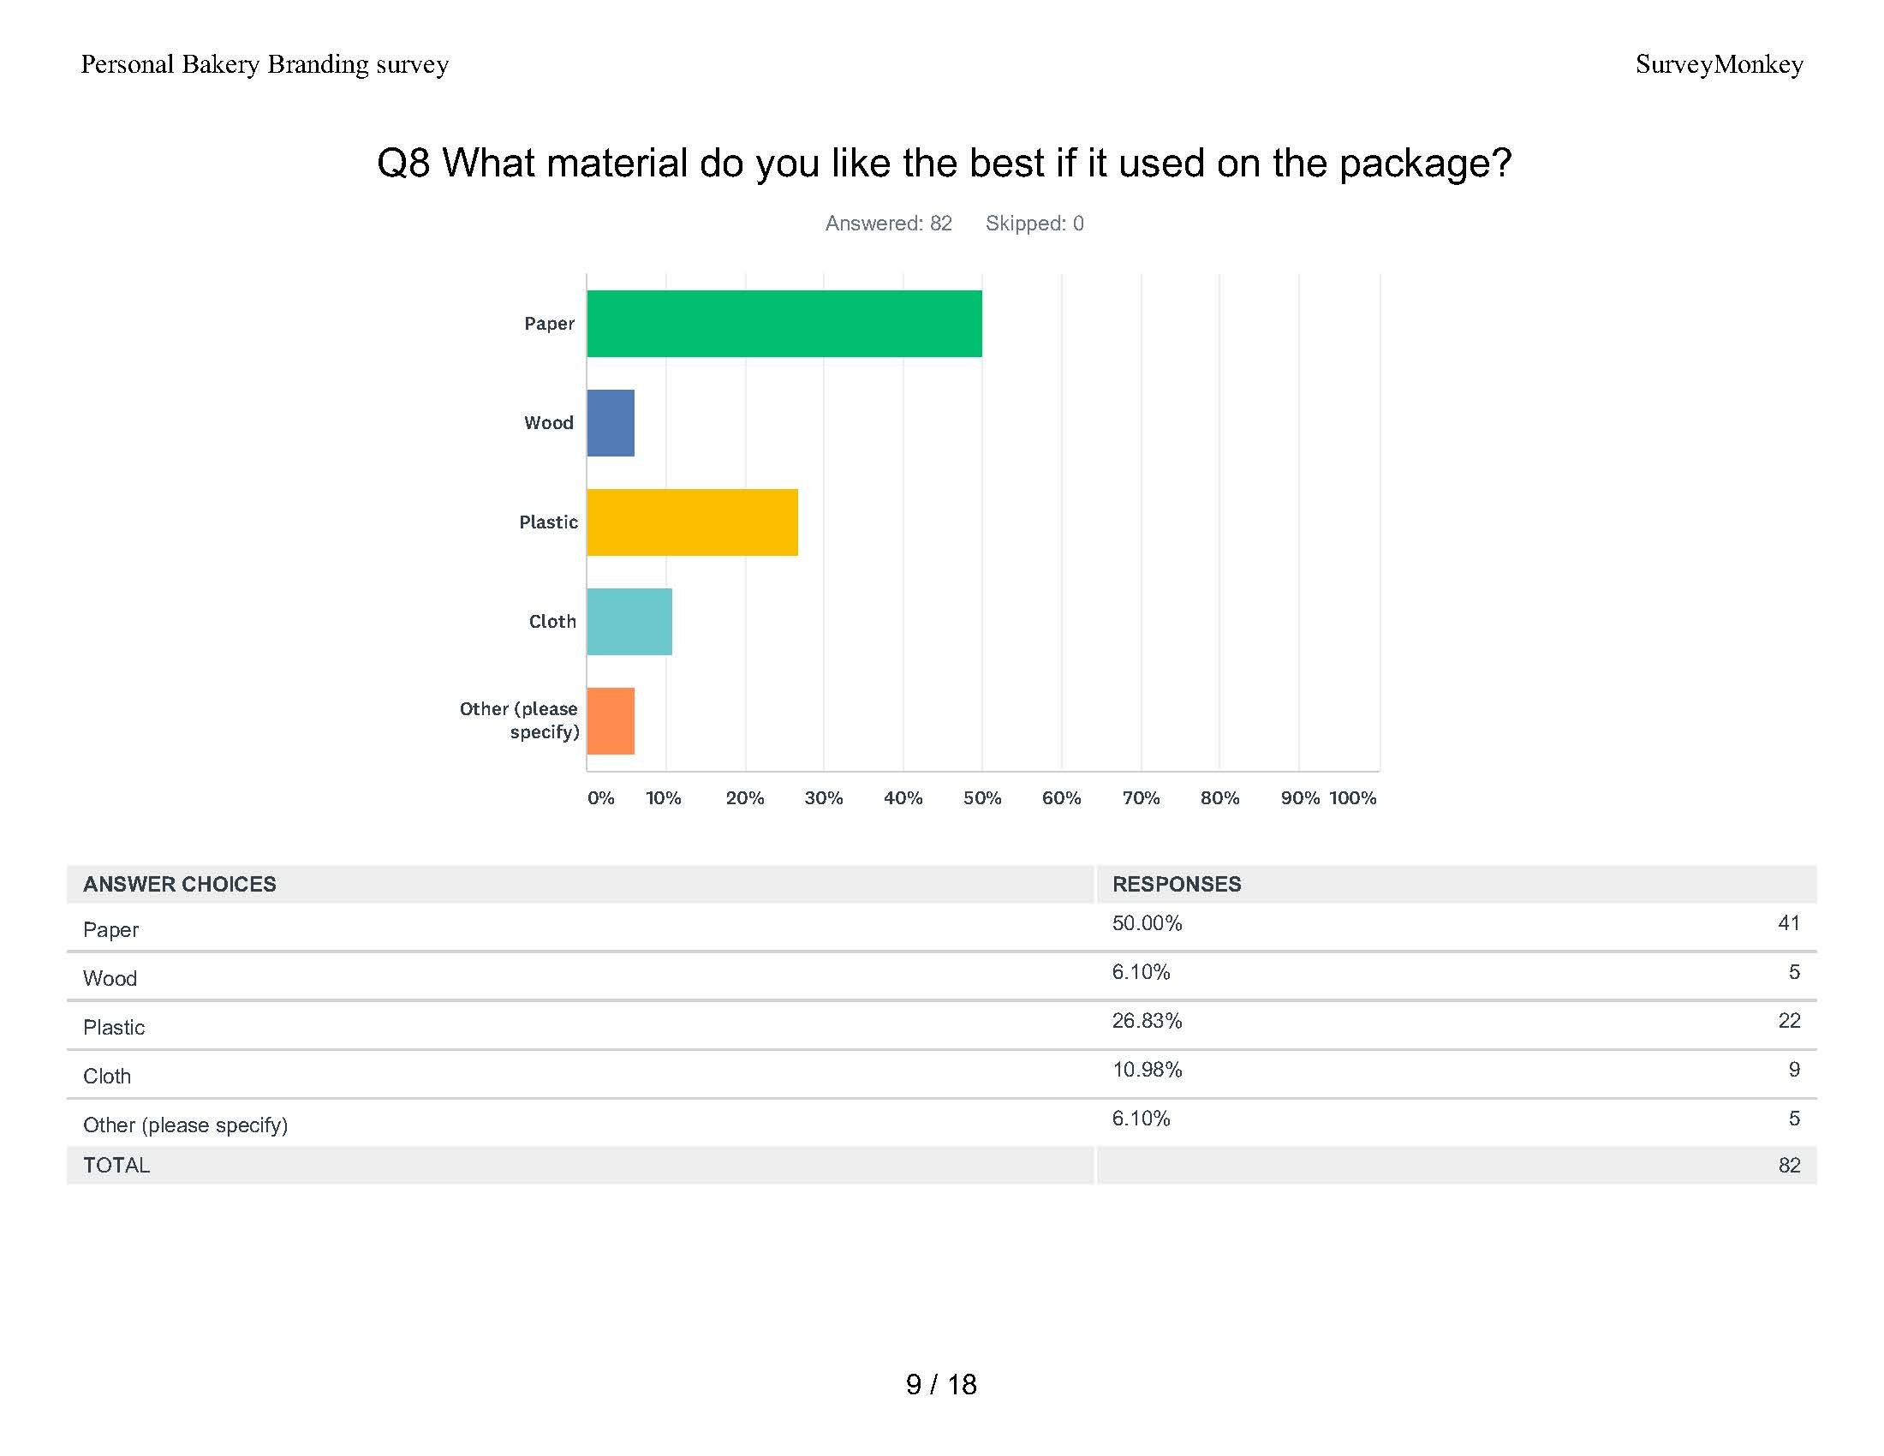
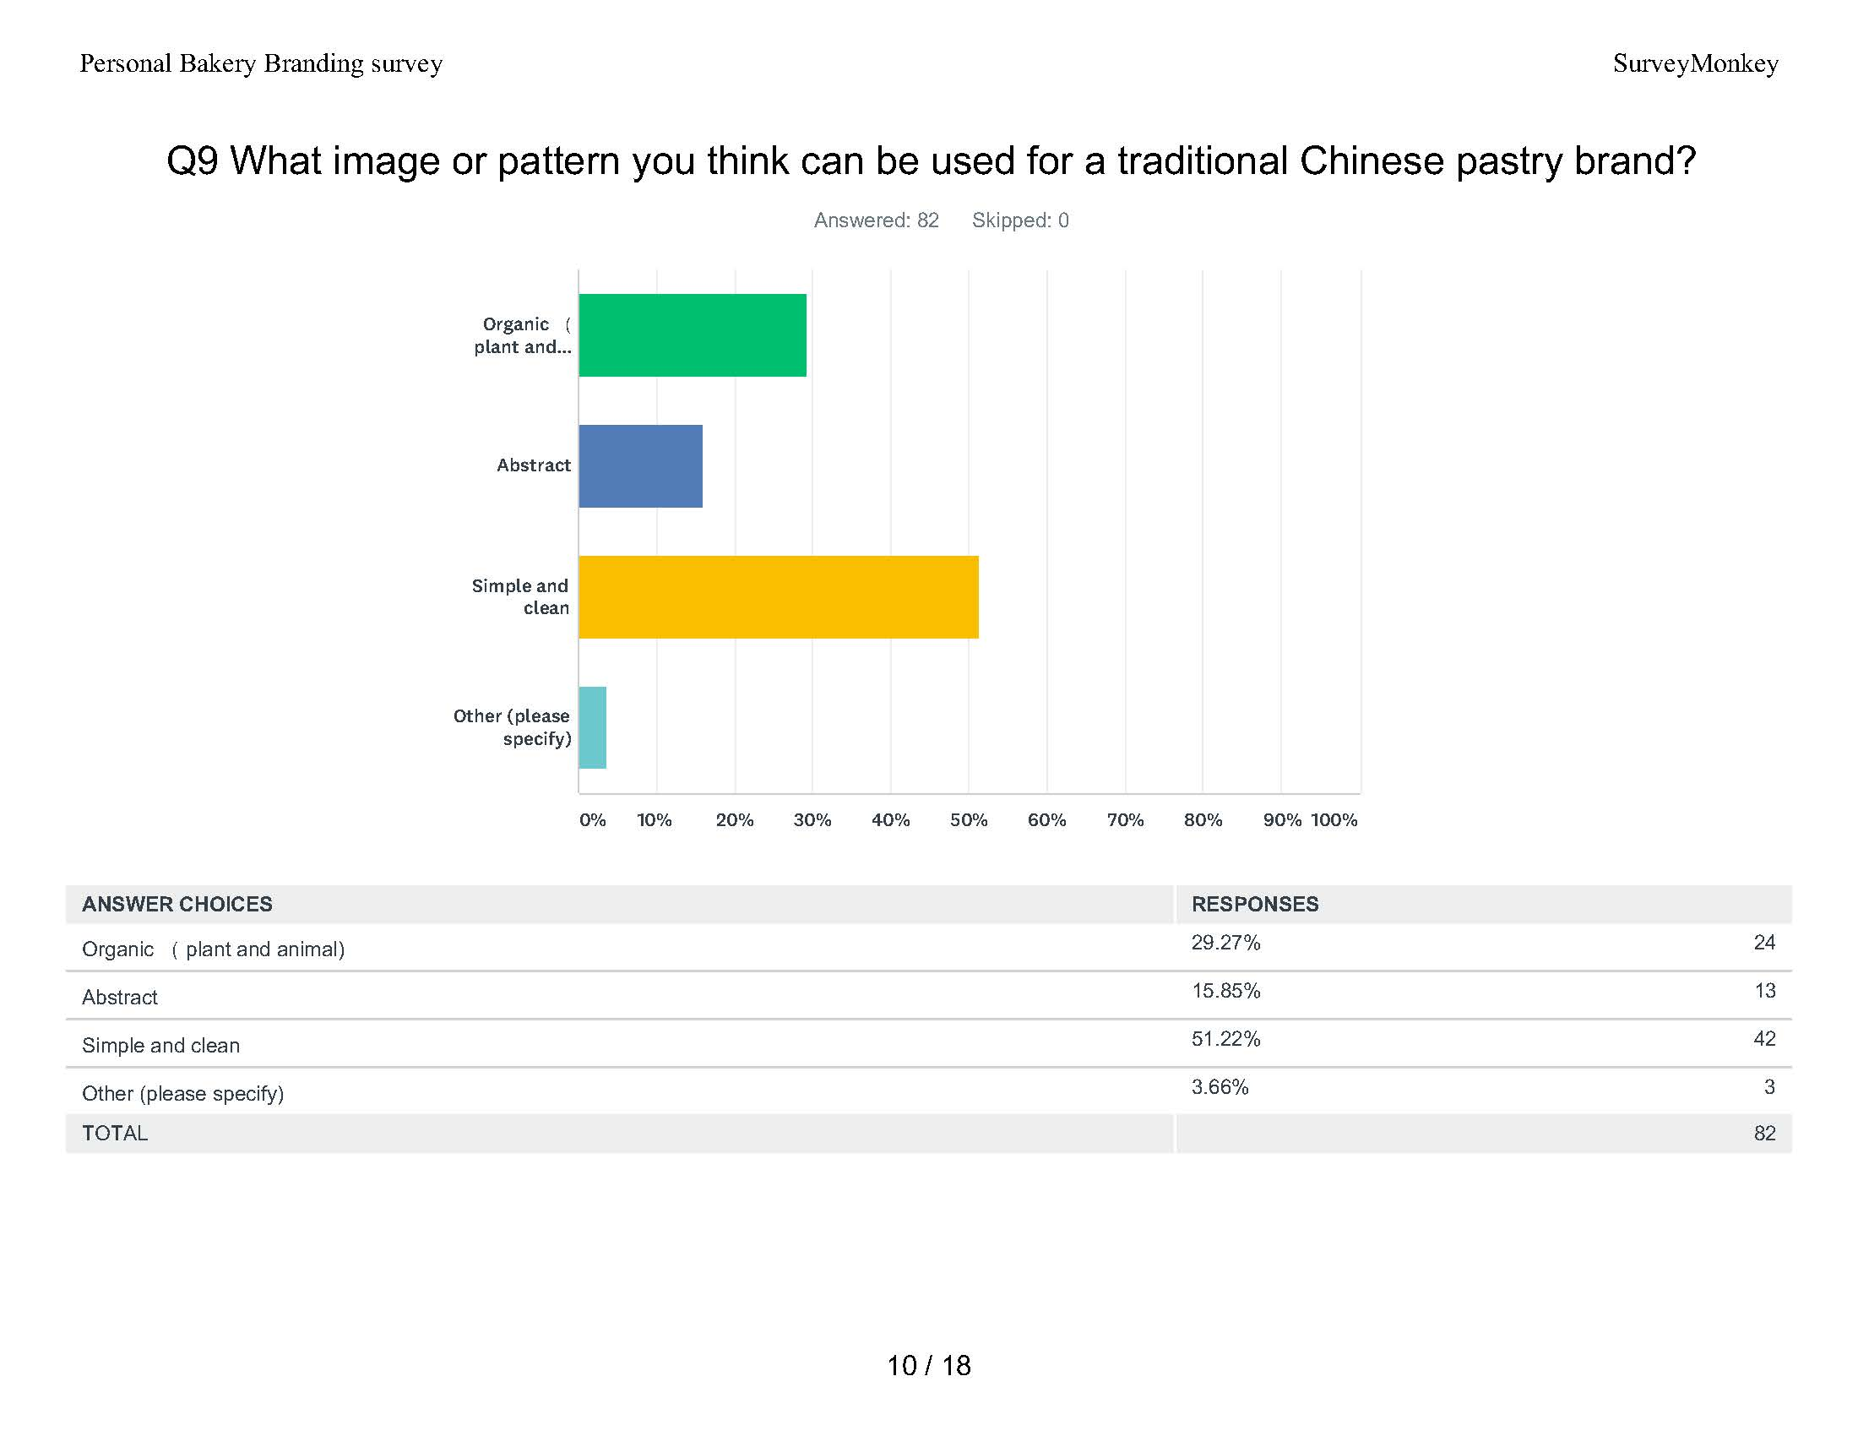
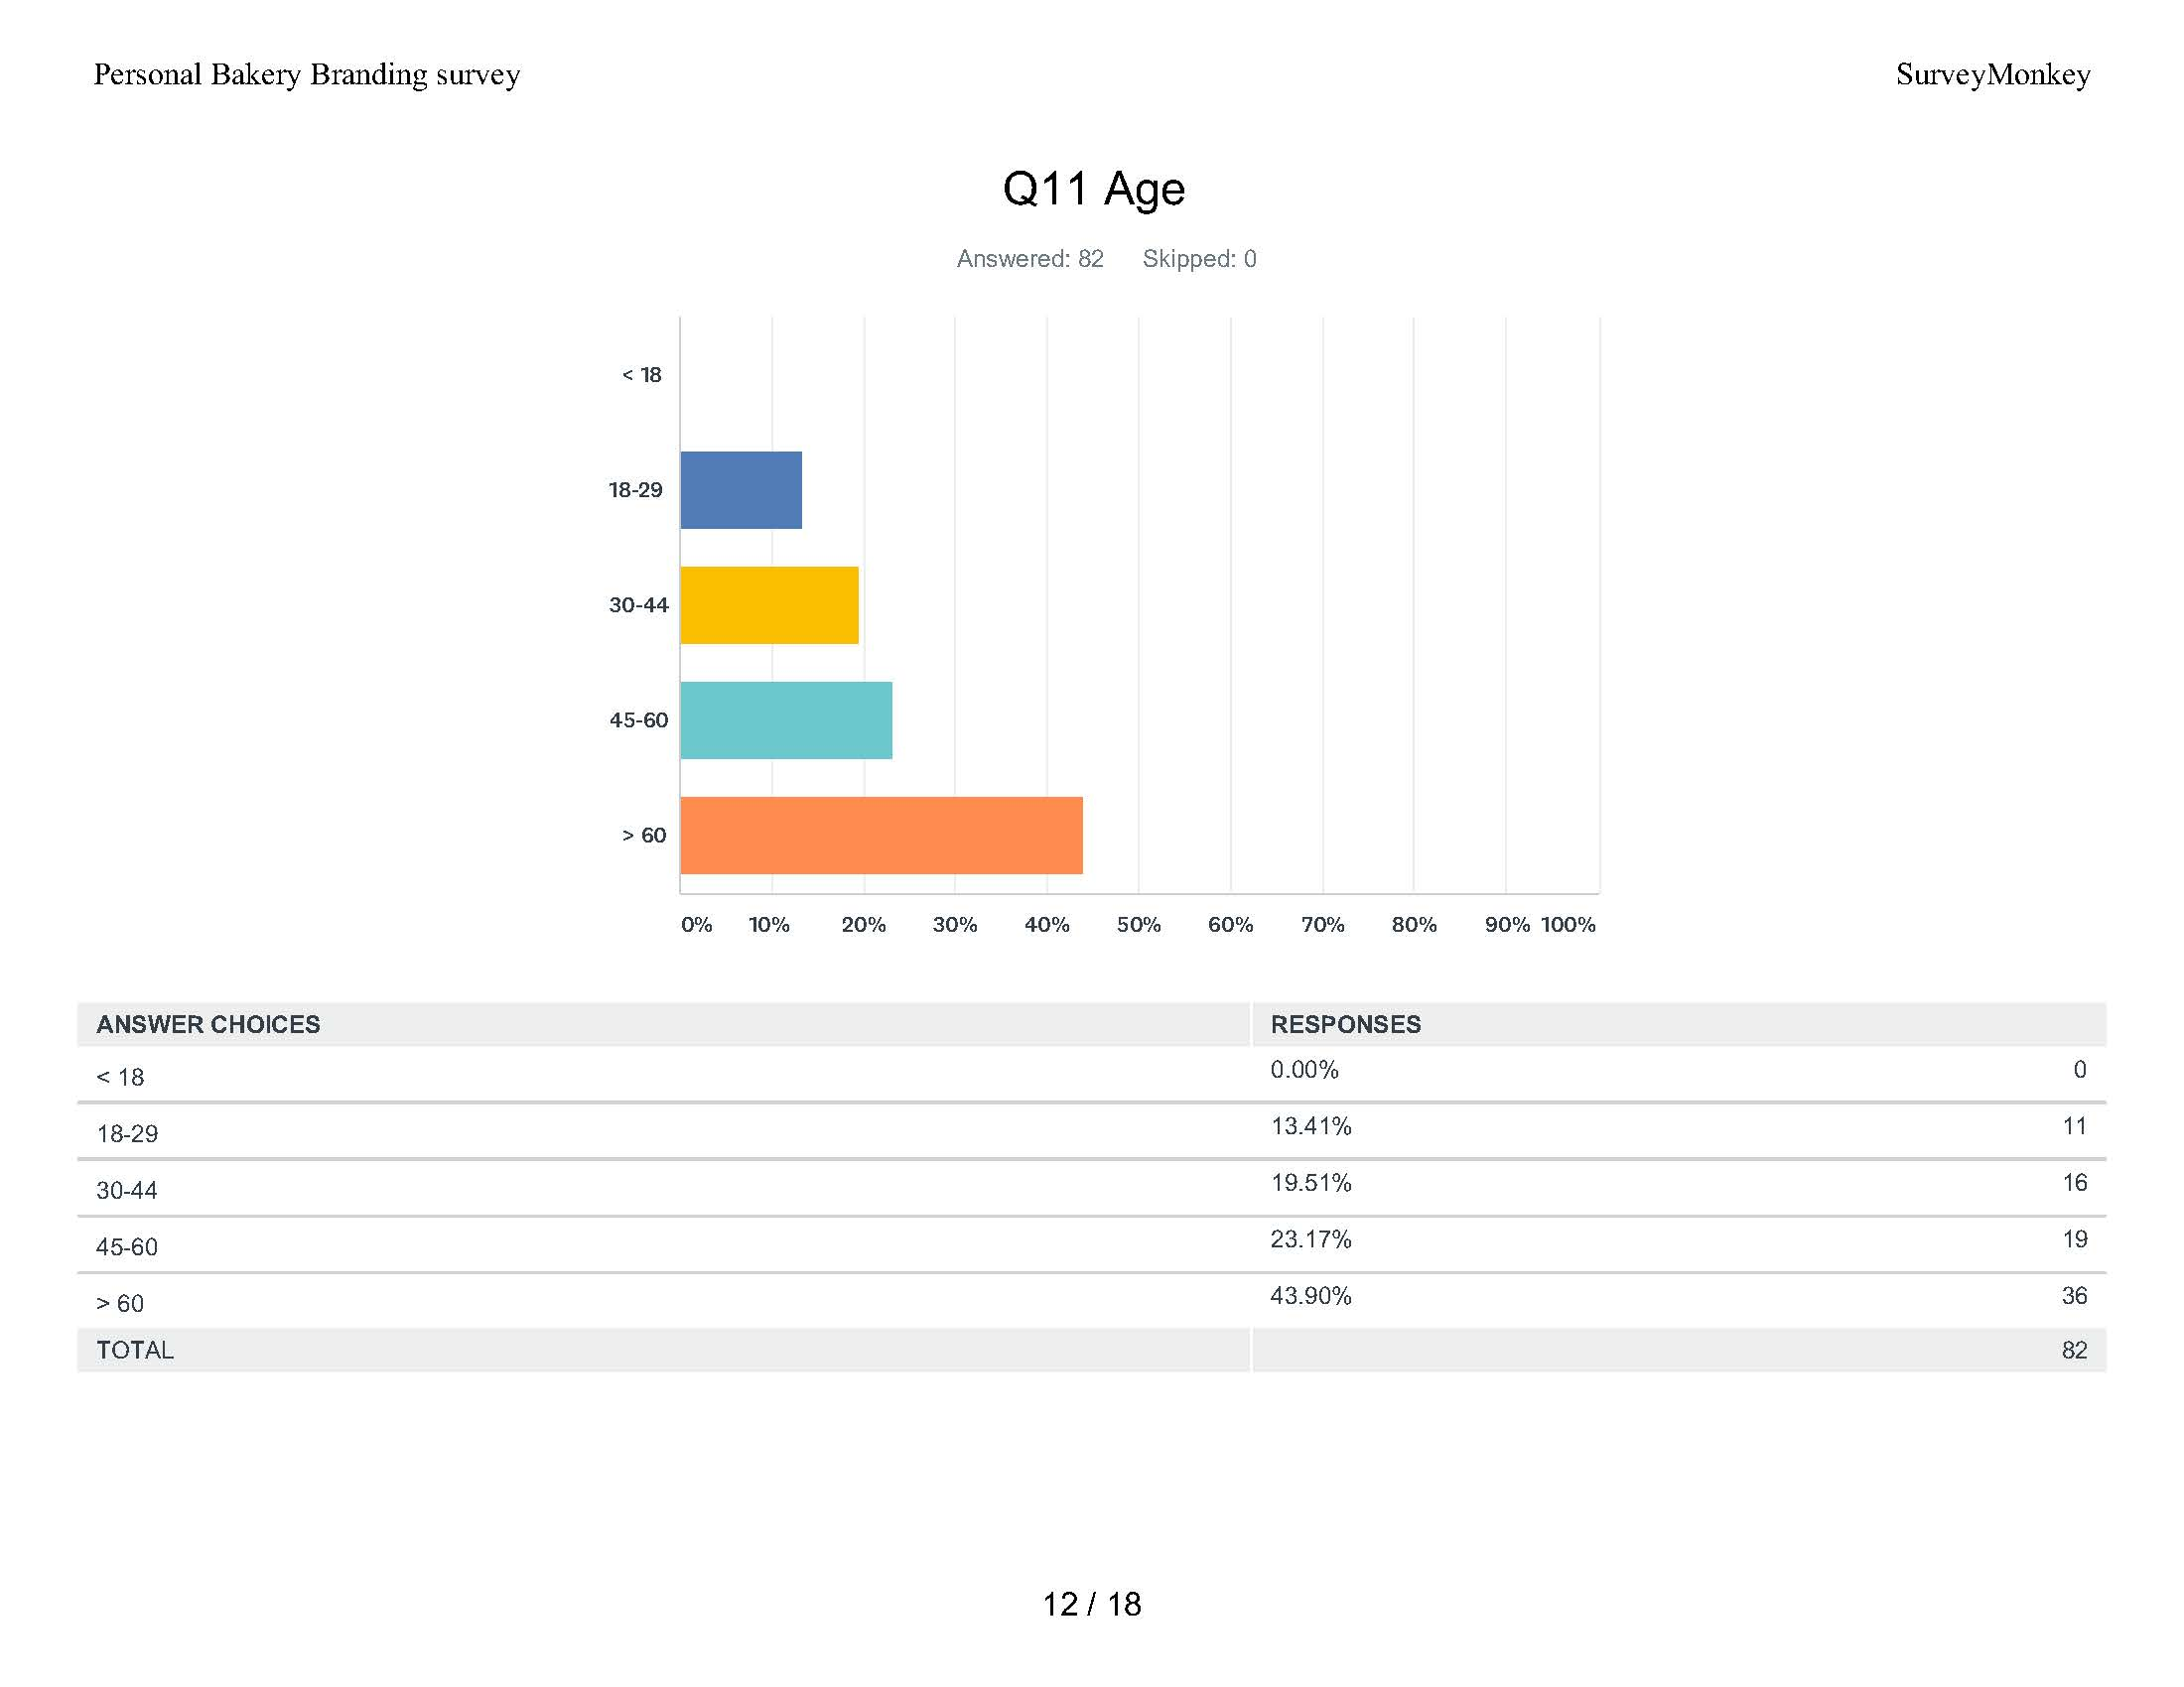
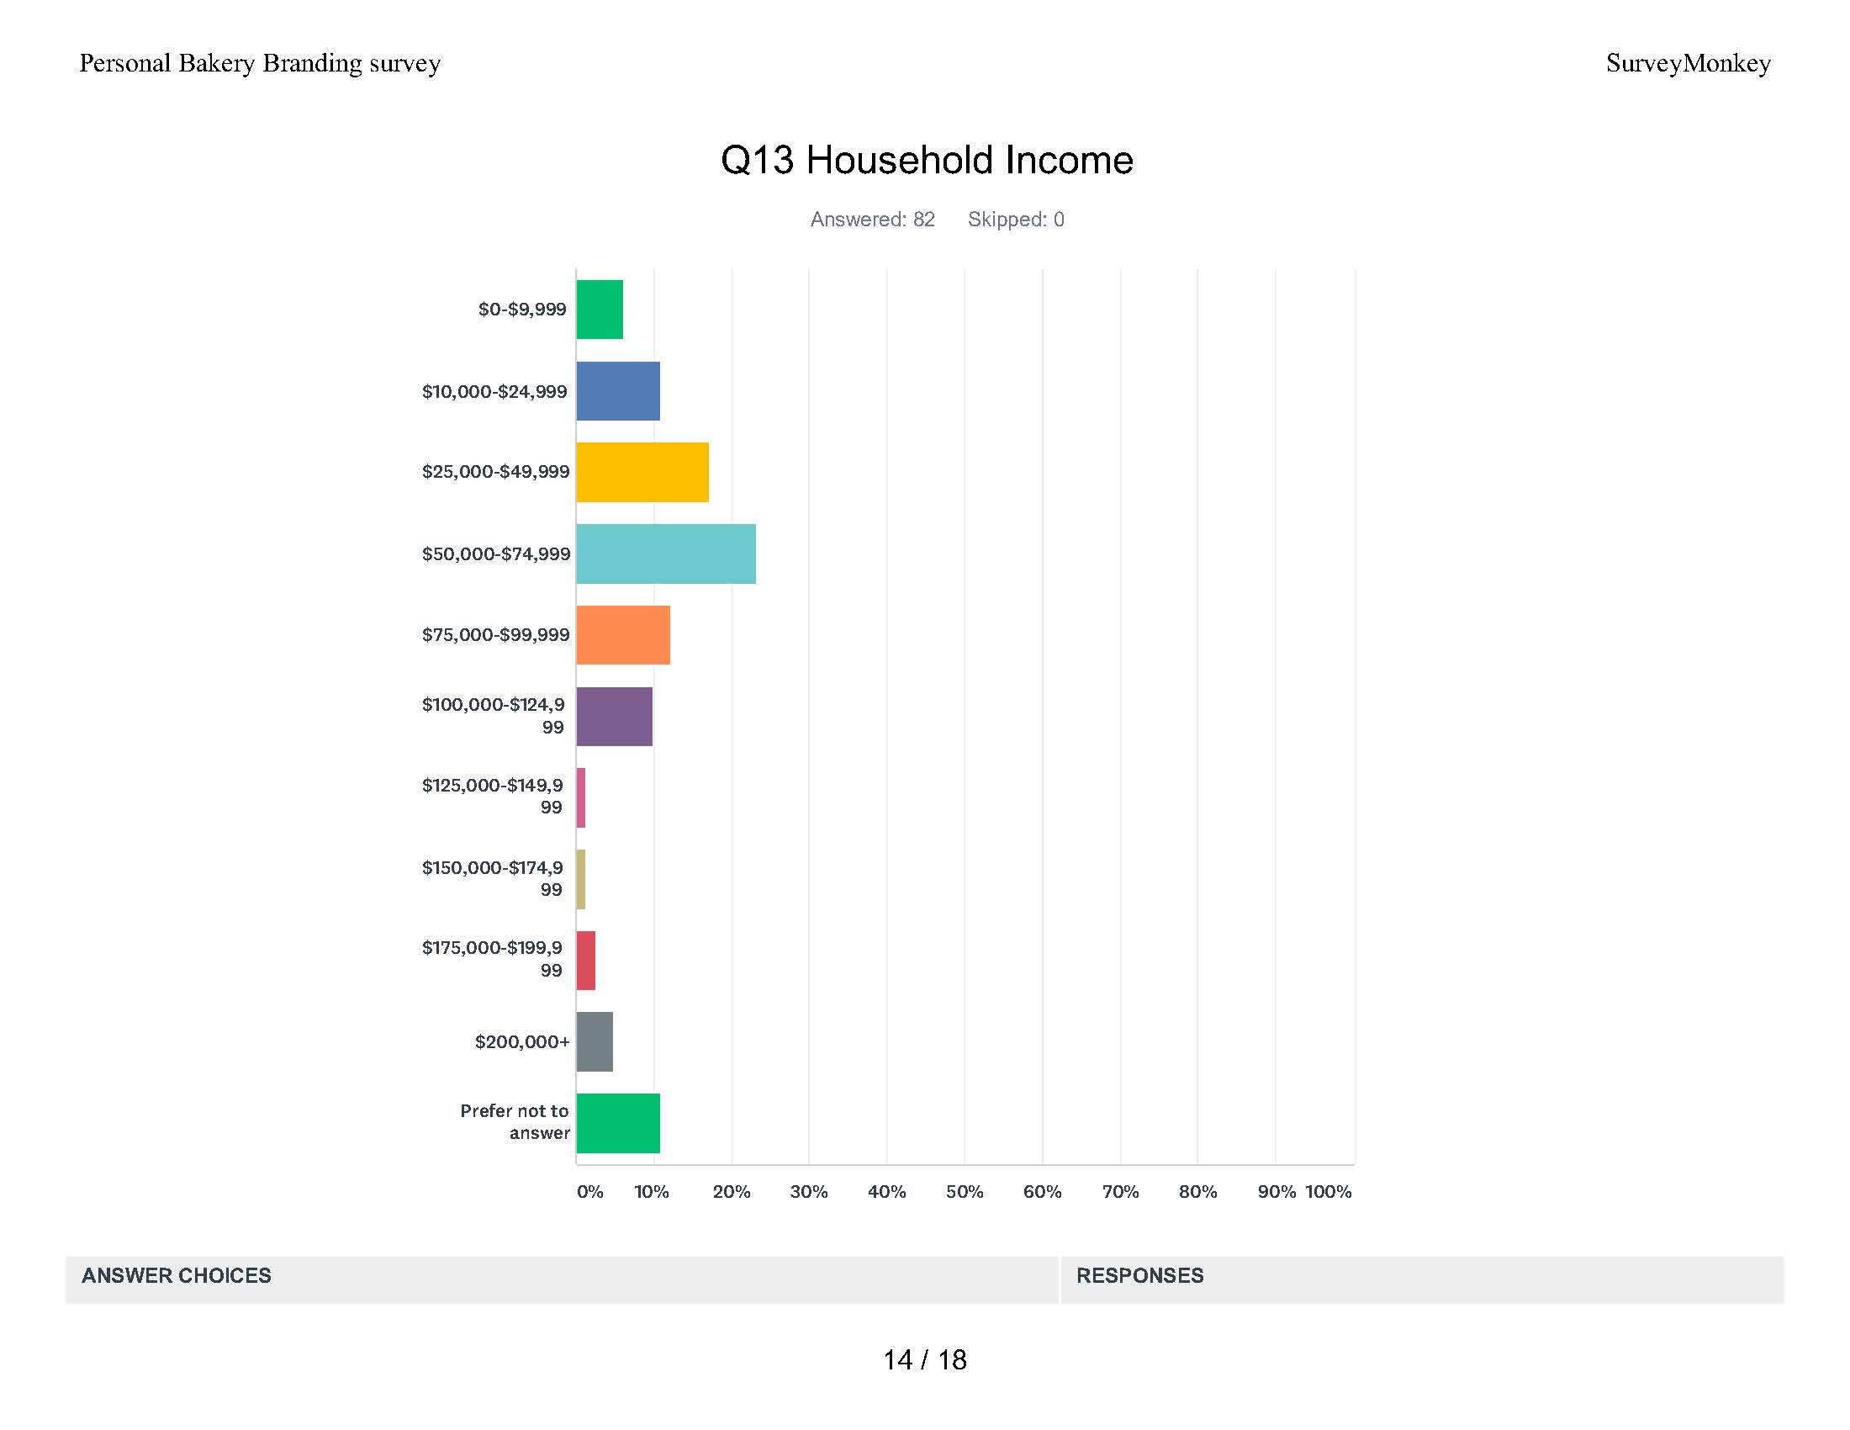

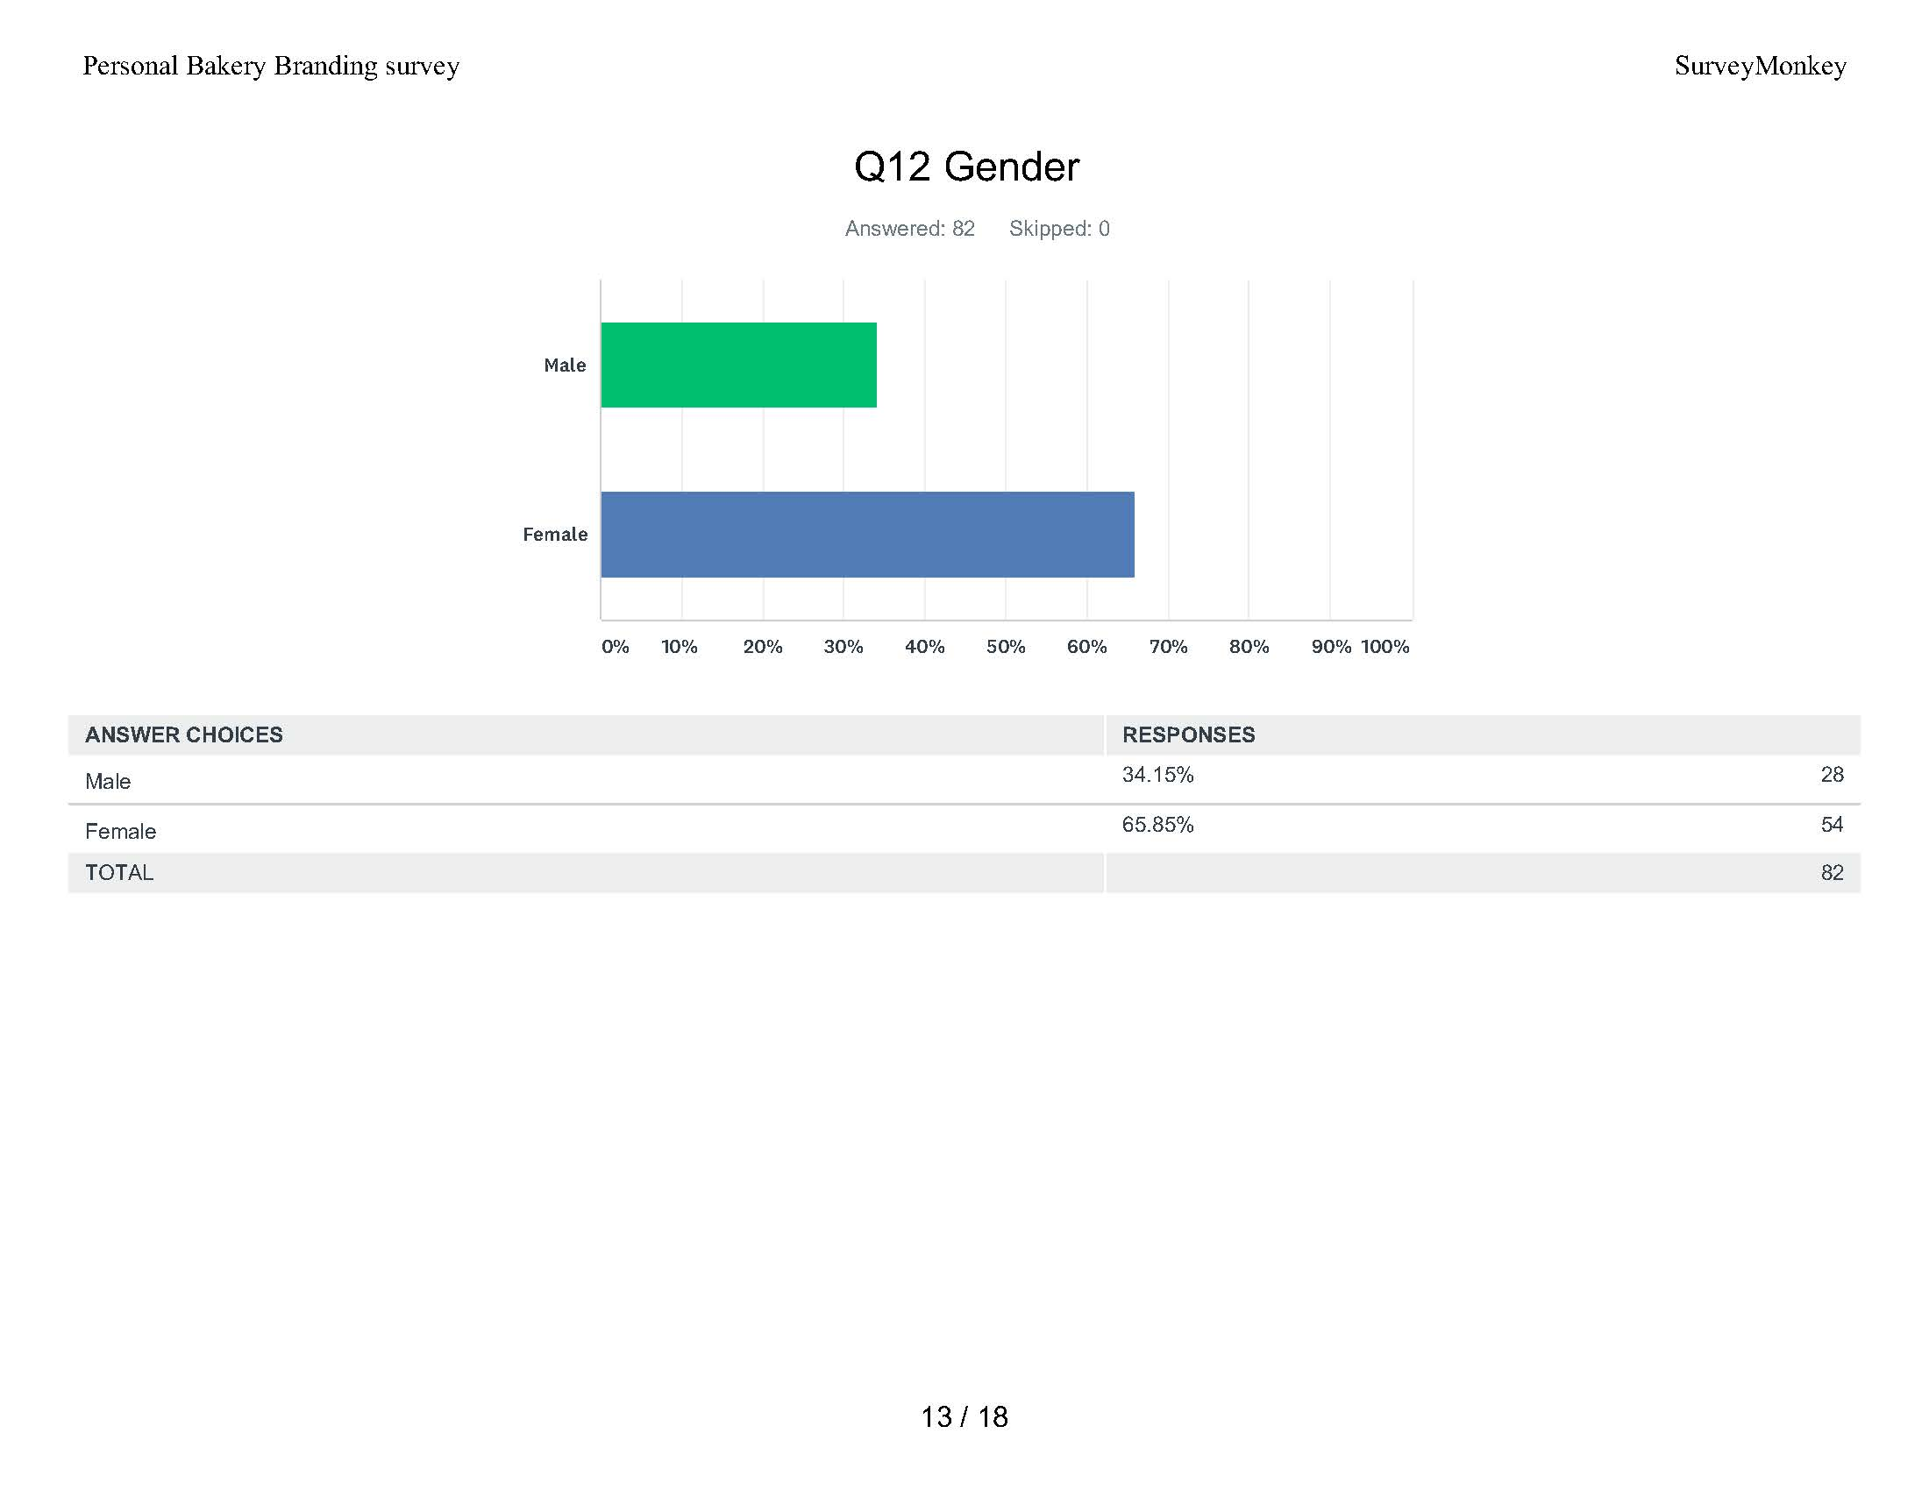
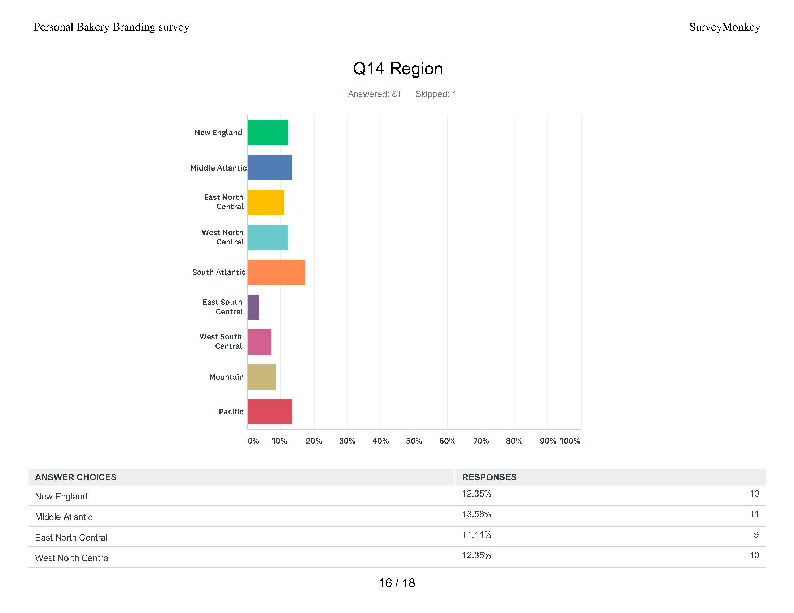

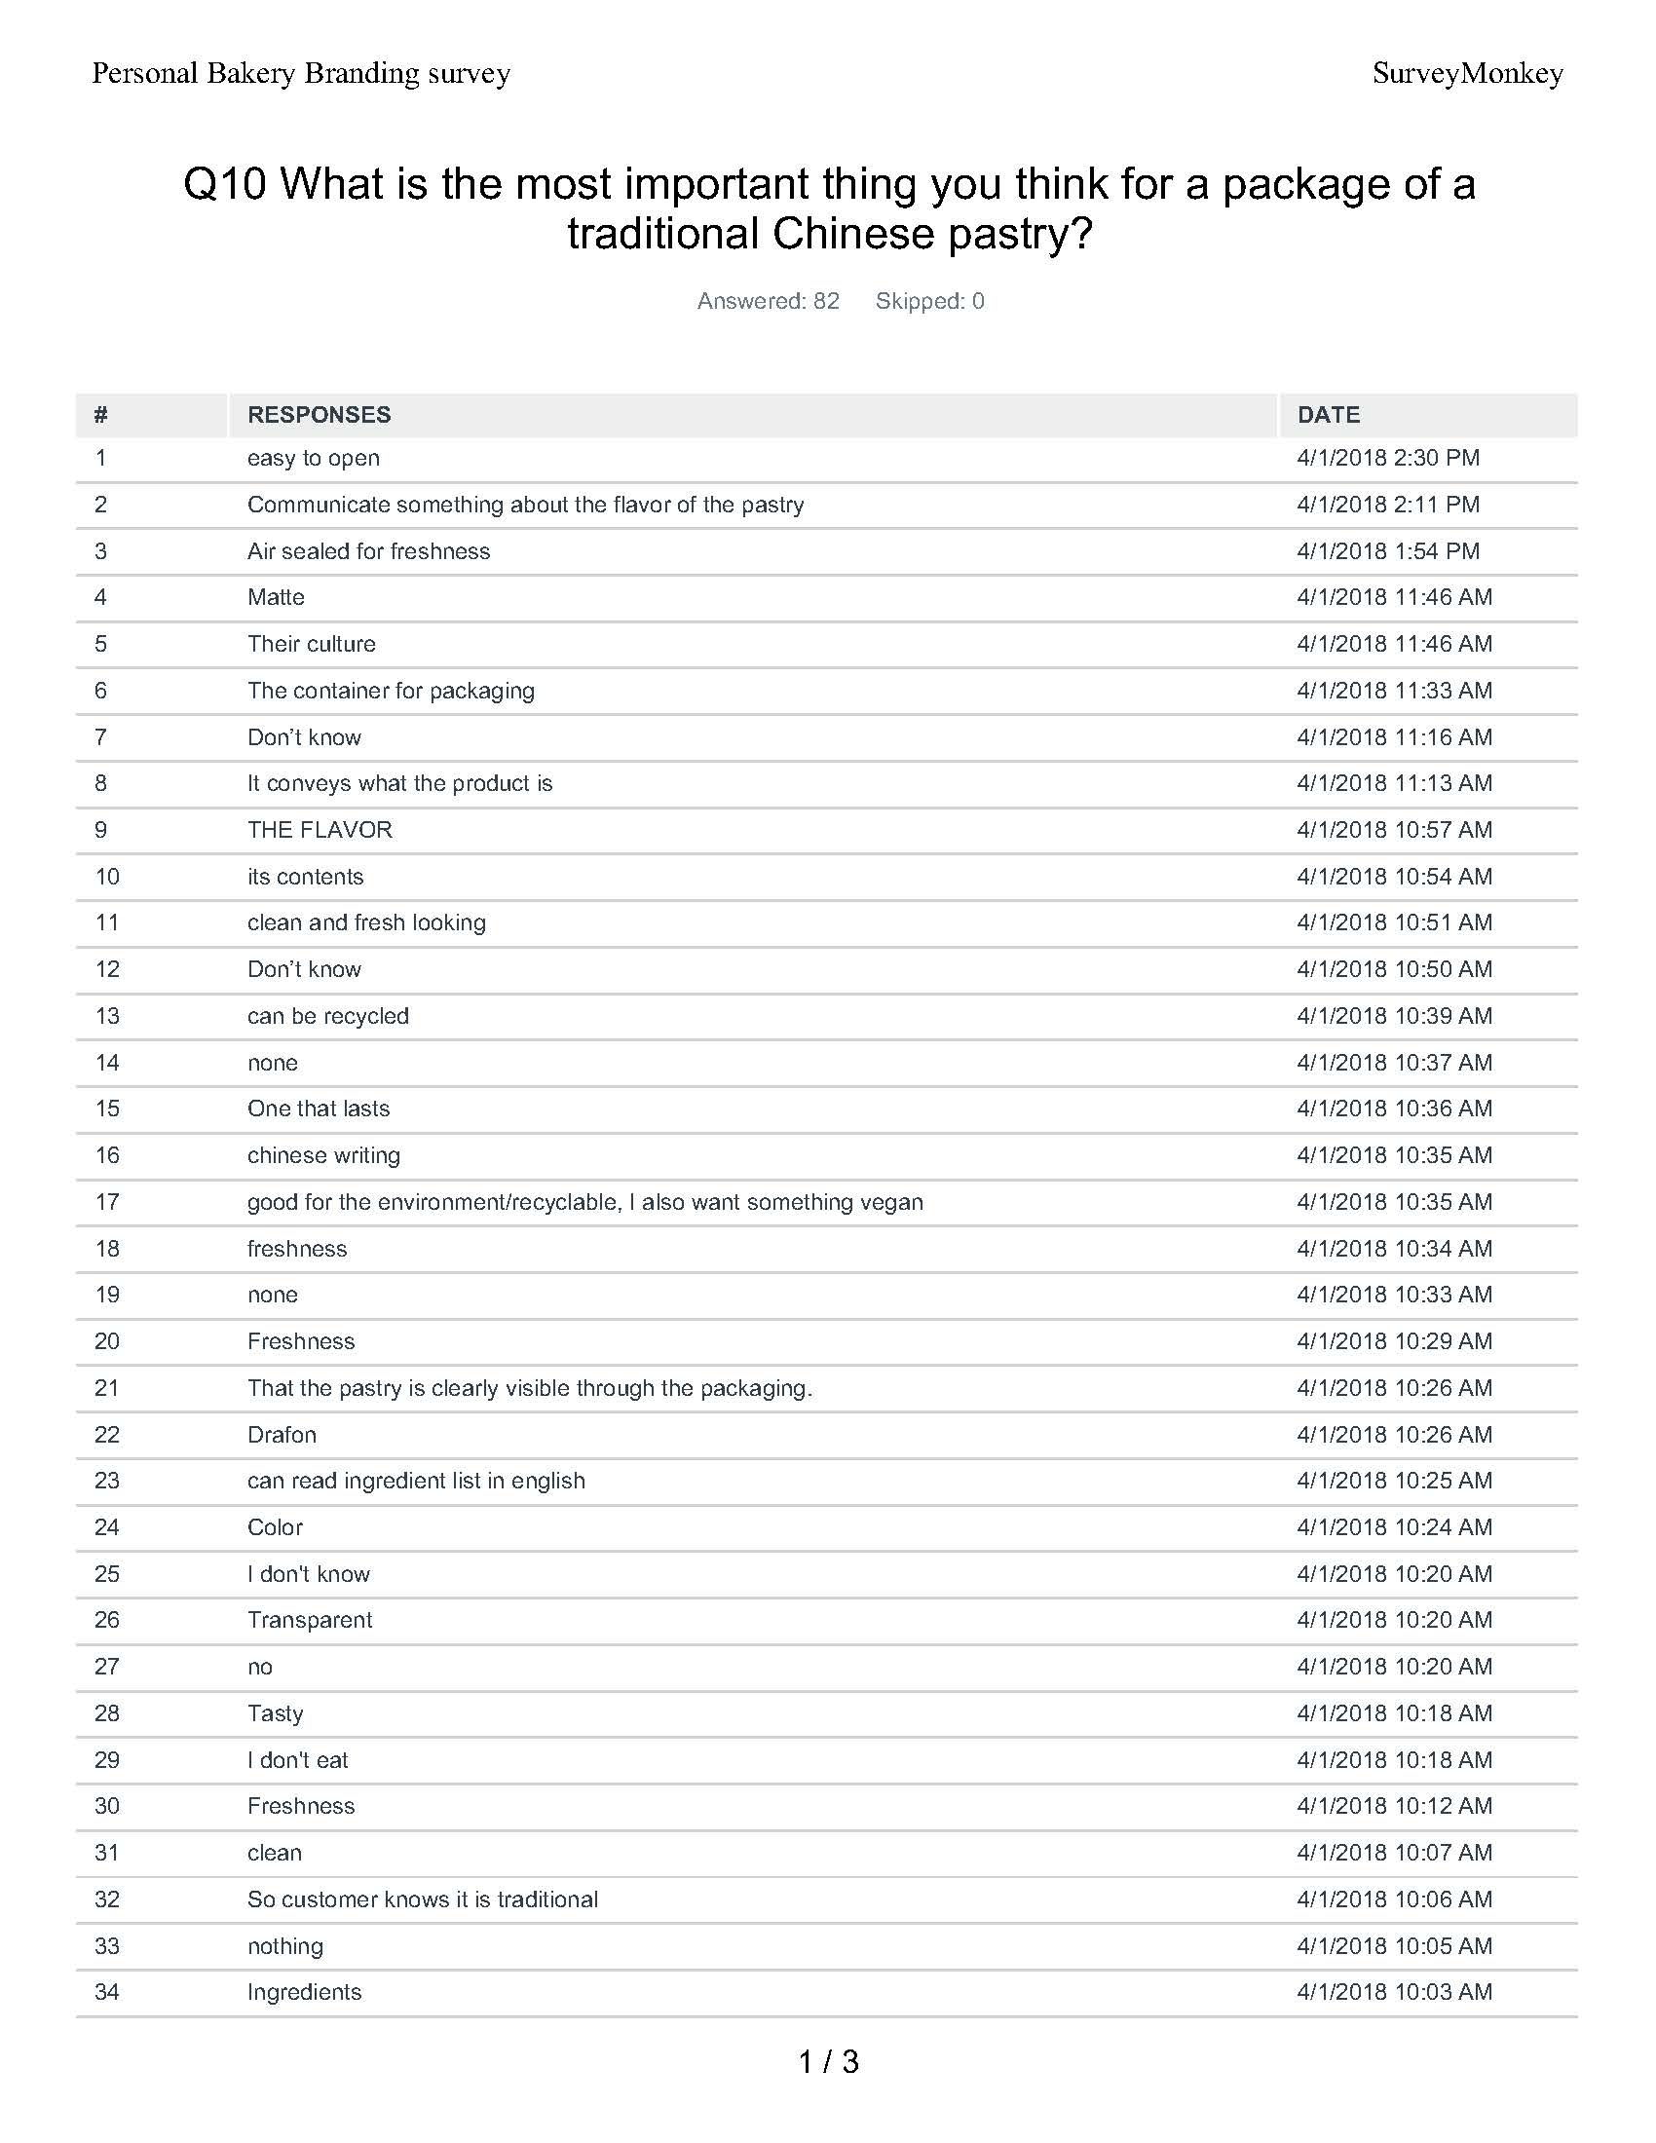
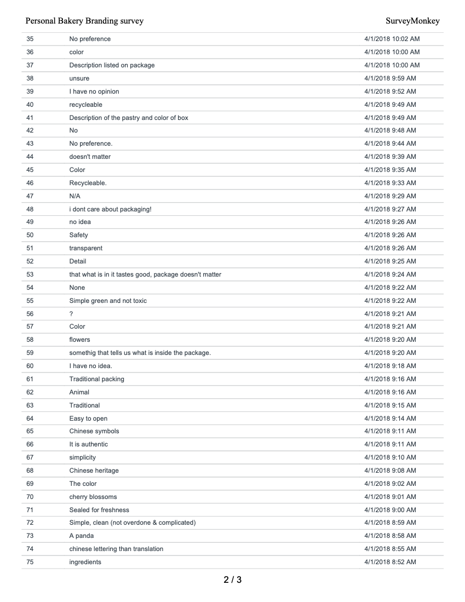
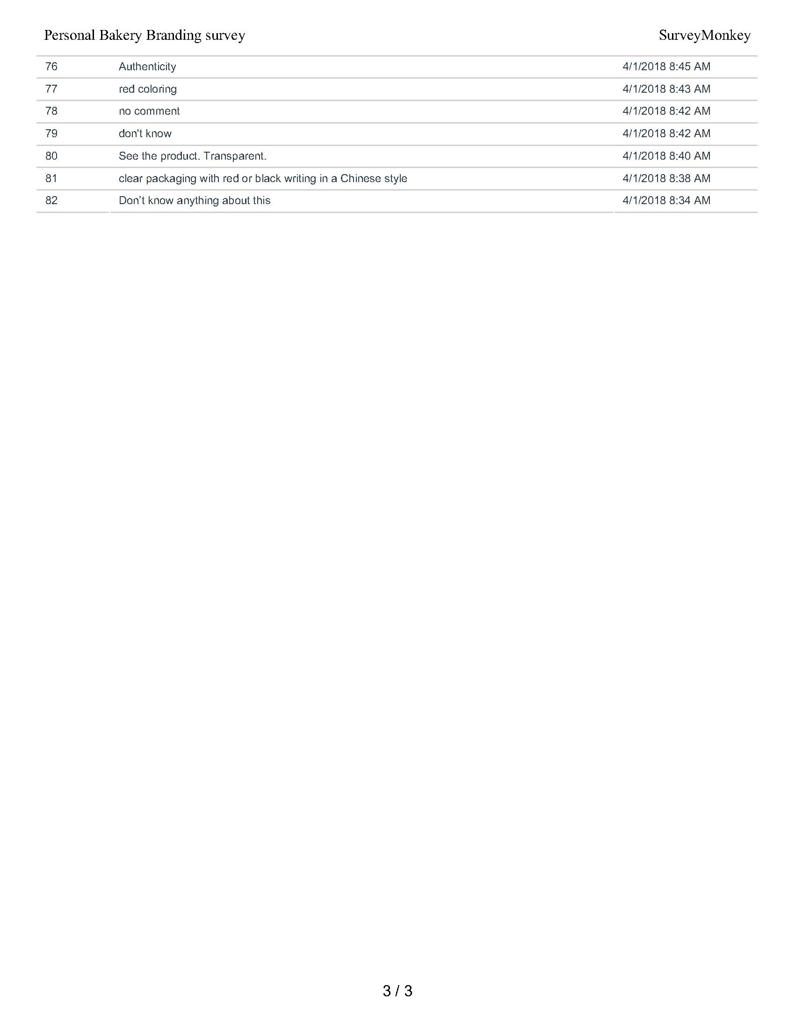

References

Abraham, S. (2016). Eating disorders. Oxford: Oxford University Press.
Birren, F. (2013). Color psychology and color therapy: a factual study of the influence of color on human life. Mansfield Centre, CT: Martino Publishing.
Elliot, A. J., Mark D. Fairchild, Anna Franklin (Ed.). (2016). Handbook of Color Psychology. Cambridge University Press.
Frascara, J., Meurer, B., Toor, J. V., Winkler, D., & Strickler, Z. (1997). User-centred graphic design: Mass communication and social change. London: Taylor & Francis.
Feigenbaum, N. (2012). Maintaining recovery from eating disorders: avoiding relapse and recovering life. London: Jessica Kingsley.
Hagtvedt, H., & Brasel, S. A. (2017). Color Saturation Increases Perceived Product Size. Journal of Consumer Research. doi:10.1093/jcr/ucx039
Ittersum, K. V., & Wansink, B. (2012). Plate Size and Color Suggestibility: The Delboeuf Illusion’s Bias on Serving and Eating Behavior. Journal of Consumer Research, 39(2), 215-228. doi:10.1086/662615
Moss, G. (2016). Gender, design and marketing: how gender drives our perception of design and marketing. London: Routledge.

