KIM TOMLINSON

STATEMENT

I am a multidisciplinary artist working across digital and analog printmaking, social practice, and writing. My work consists of several ongoing, interrelated projects that use text and conversation as a means of connecting with people. I often prompt my community in the form of social media polls or everyday conversation, then generate a relic of that moment of connection. These relics manifest in many ways, including the games and flyers. Since moving to Lincoln I’ve experienced a sense of placelessness and have had to develop new strategies for connecting, coping, and finding joy. My work reflects this through direct references to mental health and crying, and employing humor and gameplay as tools to engage viewers. As pictured below, this year I have focused on making different types of ephemera meant to be handled by the viewer, including screen prints, letterpress, digital prints, zines, and vinyl installations.

IMAGE LIST
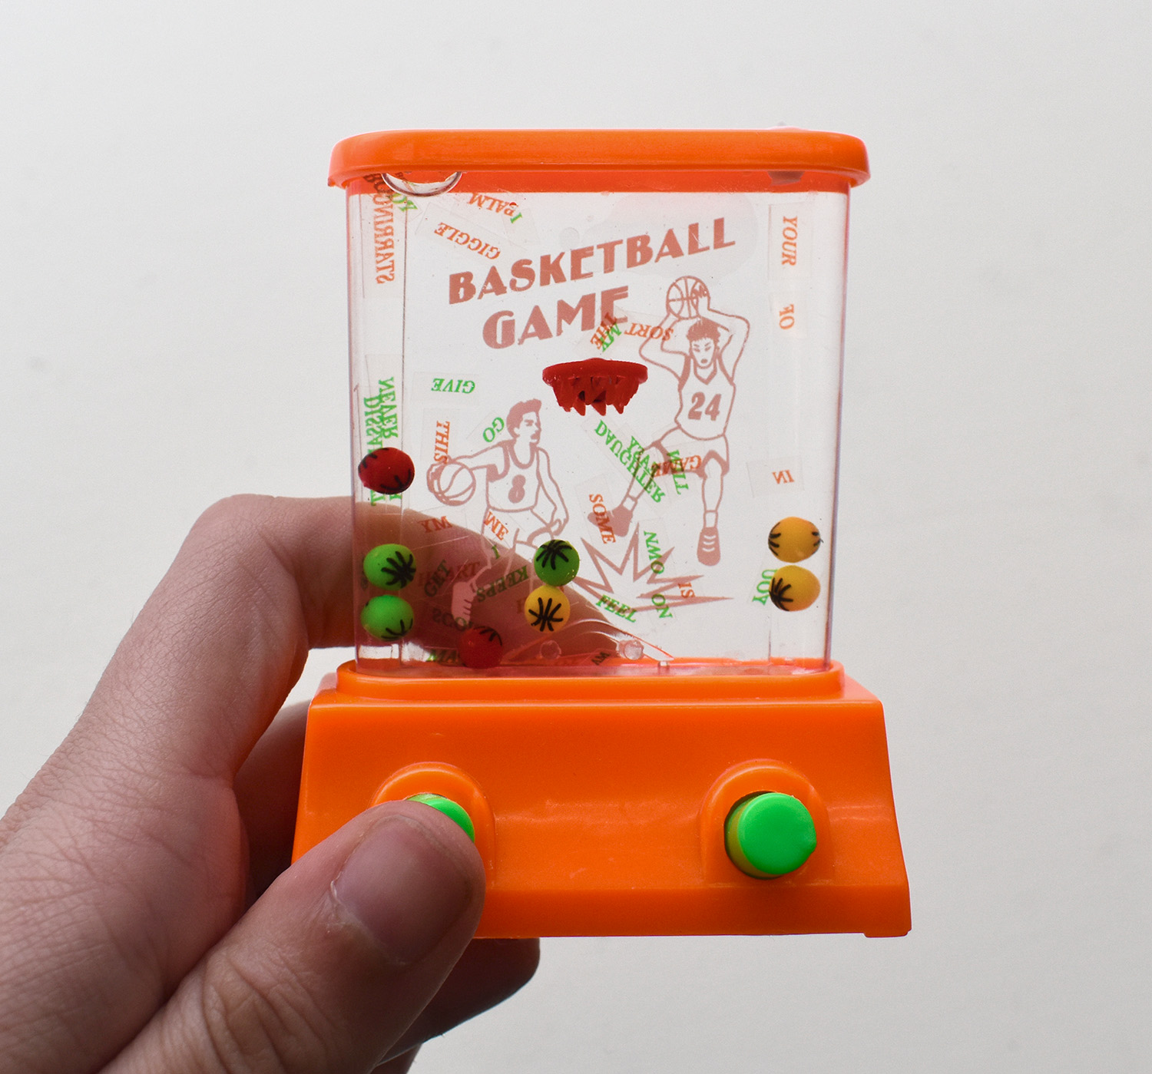  HandGame_Tomlinson_1.jpg | CRYING AT A BASKETBALL GAME  This is the first in a series of “books” inspired by the nostalgic and affordable hand games that have brought me fleeting moments of pleasure throughout my life.  In these works I physically deconstruct text messages from my ex, and insert them into a playful context, stripping them of their former meaning (and bad vibes).  The variable nature of the game allows the viewer to concentrate on both the significance of the individual words and the visual beauty of the bending, twisting letter forms in space. The words become floating, playful, original ideas subject to the interpretation of the player.
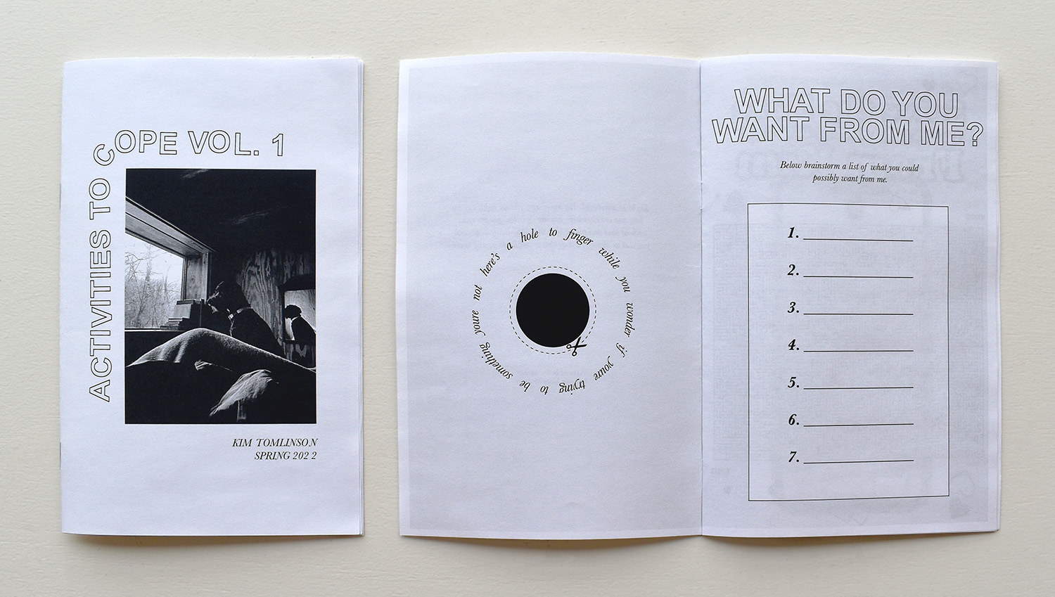  ActivityZine_Tomlinson_2 | ACTIVITIES TO COPE VOL. 1  This zine is part of an ongoing collection of experimental activities, including mazes with hidden messages, a “draw your own group therapy zoom call,” an “emergency hand to hold,” and more. Activities are based on my own experiences and needs, but are also generalized and meant to be relatable to a broad audience. Aesthetic references are pulled from the 1970’s Lesbian Herstory Archive newsletters.
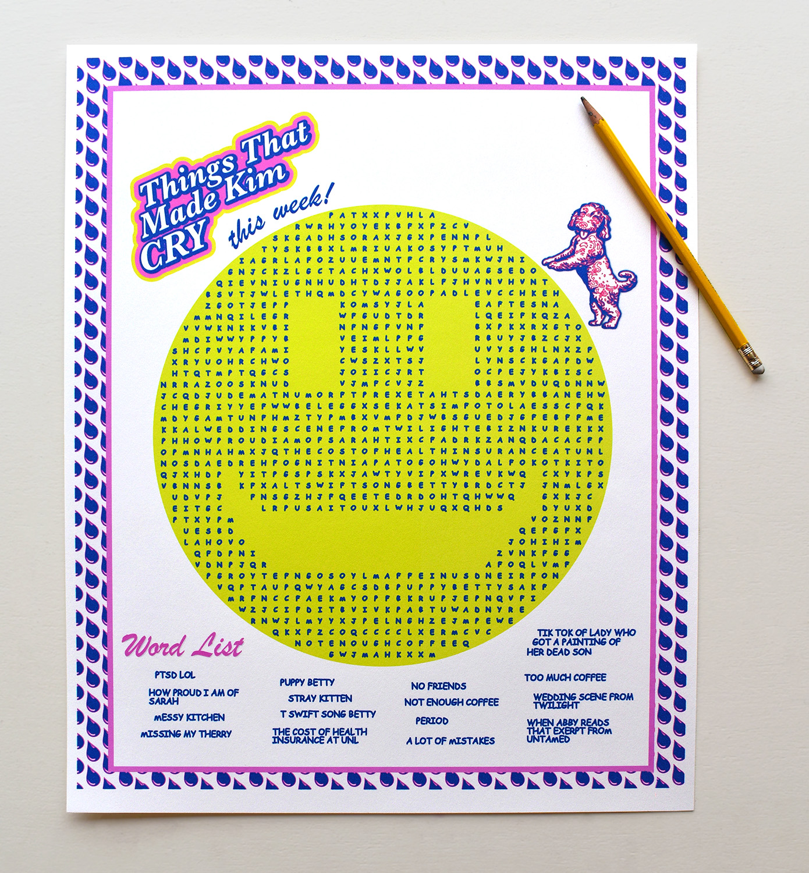  JumboWordSearch_Tomlinson_3 | THINGS THAT MADE KIM CRY: THIS WEEK!  This is one of a set of jumbo activity pages that I made as weekly reflections for my first semester in Lincoln. The content is always based on my personal experience, and is meant to add levity and irony to otherwise vulnerable topics.
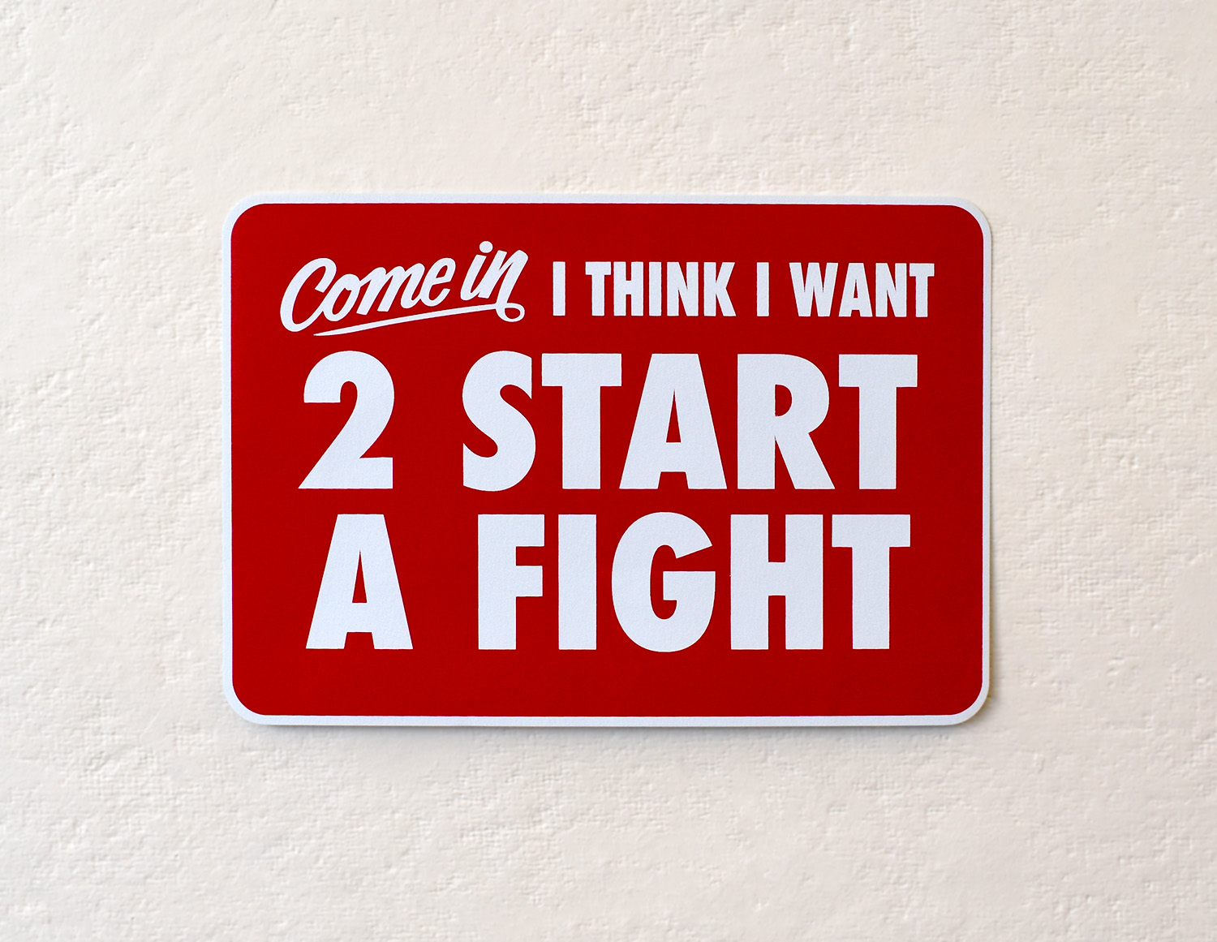  OpenSign_Tomlinson_4 | COME IN!  This print is a play on classic “Come In, We’re Open!” signs. Throughout my work there is a tension between wanting connection but maintaining a sense of separation at the same time. In this piece I attempt to showcase this tension, while using humor to process personal emotion.
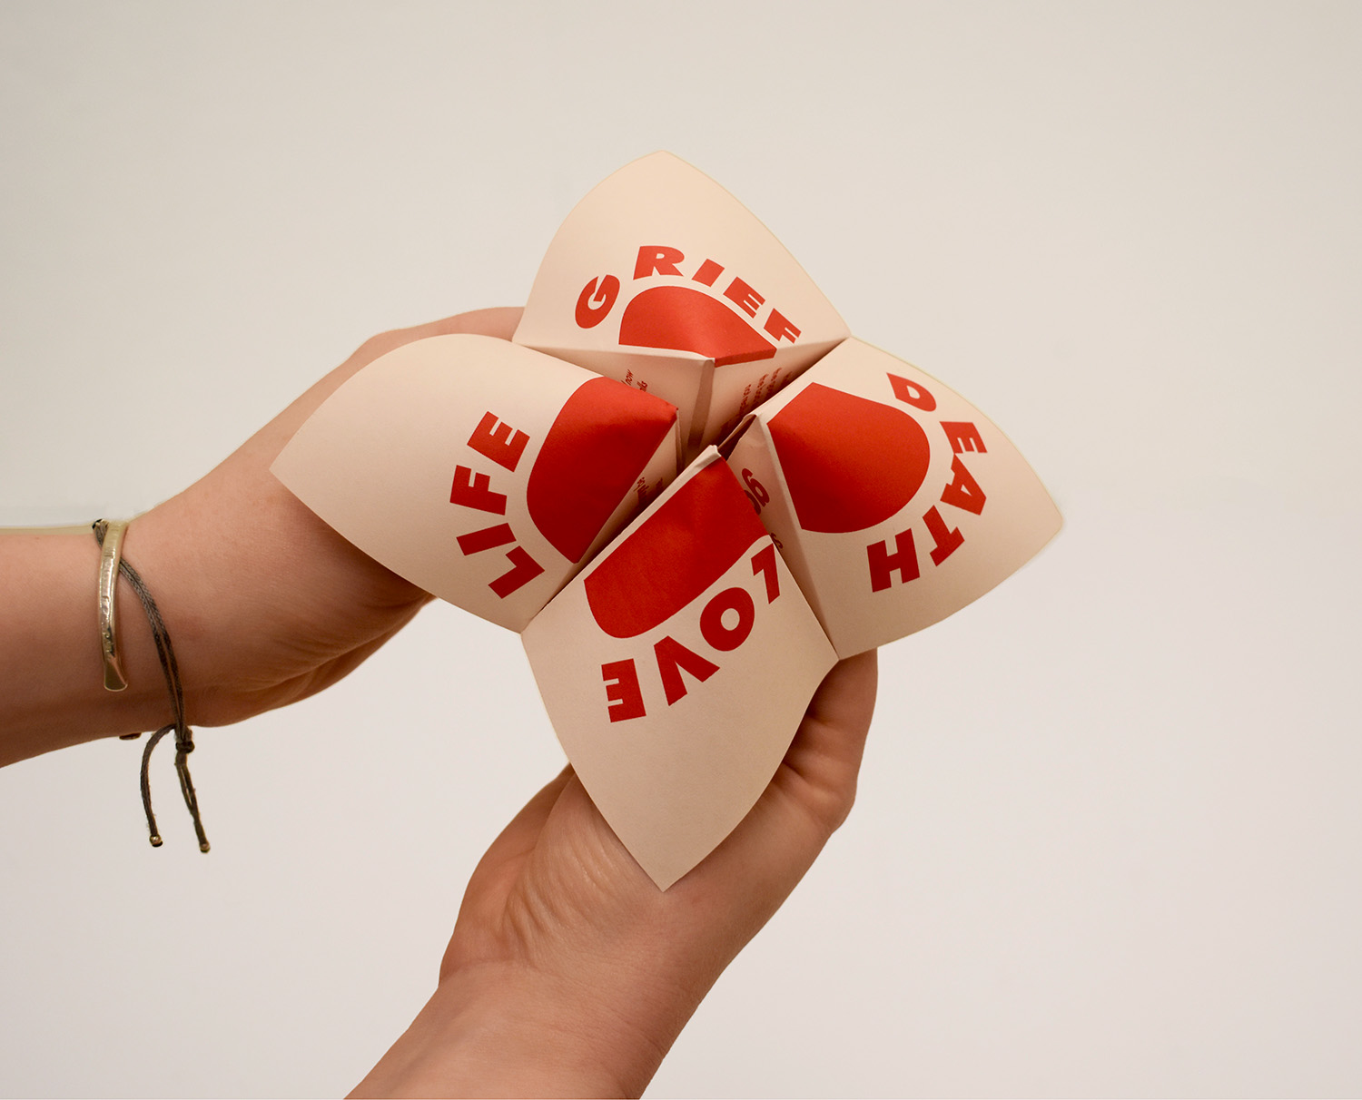  CootieCatcher_Tomlinson_5 | EVERY THERAPIST I’VE EVER HAD IS NAMED HOLLY  One of a set of folded origami-type fortune tellers (also known as “cootie catchers”) inspired by my experience designing and sharing these with other girls throughout my childhood. The objects act as tools for connection and curating a future. For this project I collected advice from my former and current therapists (both named Holly) and now offer it to my viewer byway of a game.
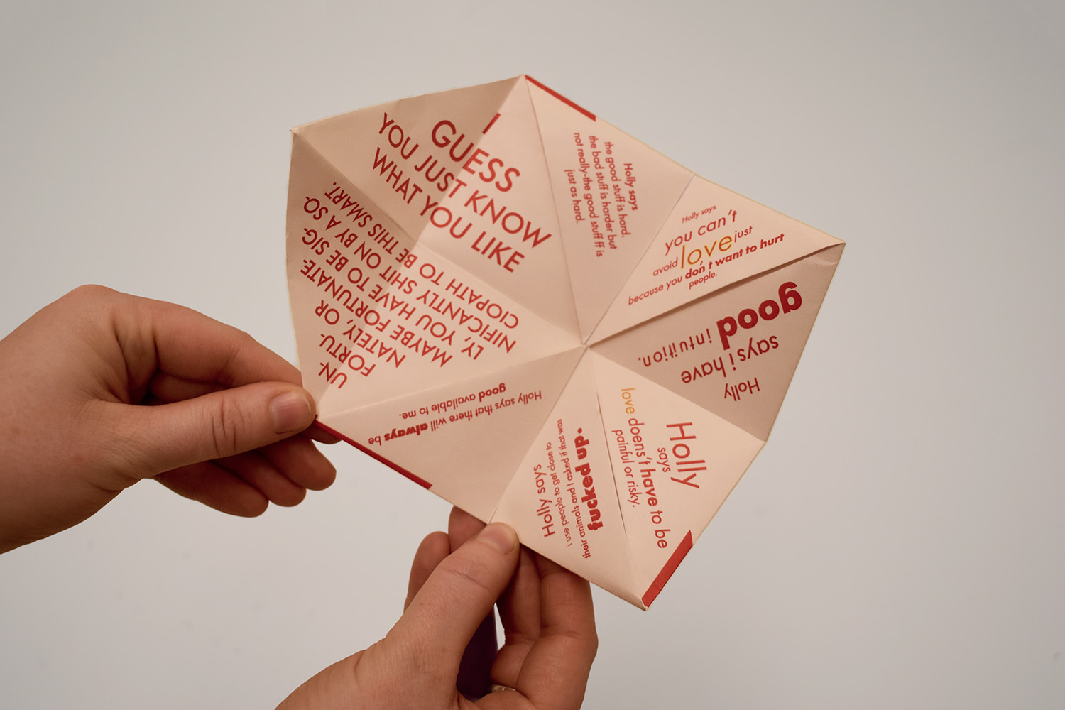  CootieCatcher_Tomlinson_6 | EVERY THERAPIST I’VE EVER HAD IS NAMED HOLLY (OPEN)  Pictured here is the interior of the fortune teller. The rules of game play are flexible, so viewers are expected to determine their fortune using their own creative interpretation.
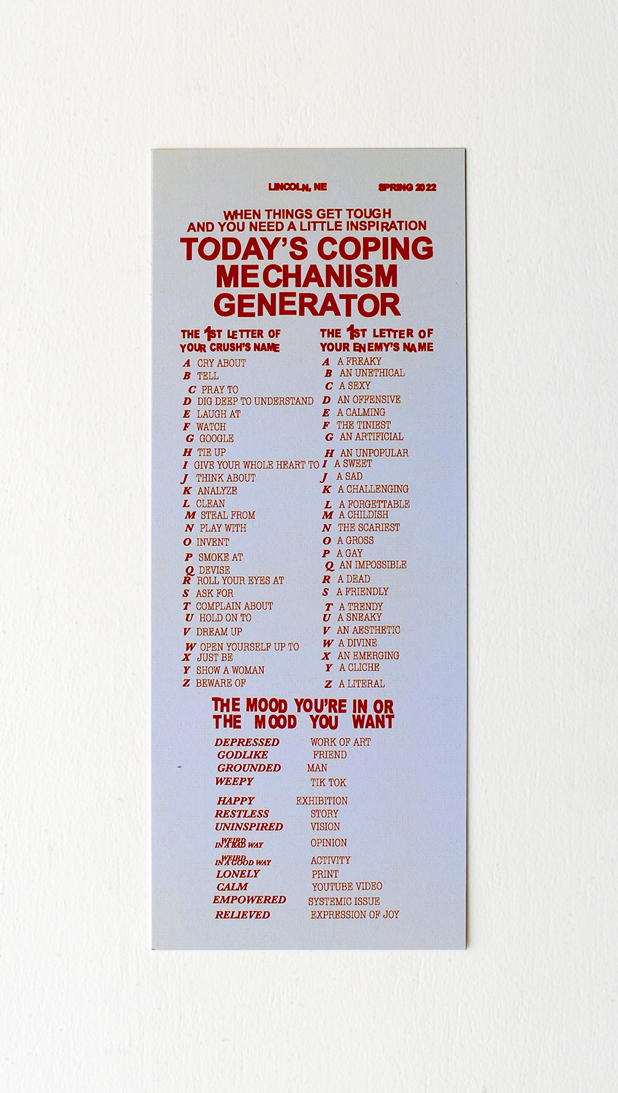  CopingMechanism_Tomlinson_7 | CRY ABOUT AN OFFENSIVE MAN (TODAY’S COPING MECHANISM GENERATOR)  In the spirit of the “event scores” of Fluxus artists who inspire me so much, I developed a tool to help inspire me when I’m in a creative/emotional rut. The goal is that any viewer can generate a personalized “coping mechanism” based on very of-the-moment criteria. The generator requires self reflection and individual interpretation of bizarre prompts.
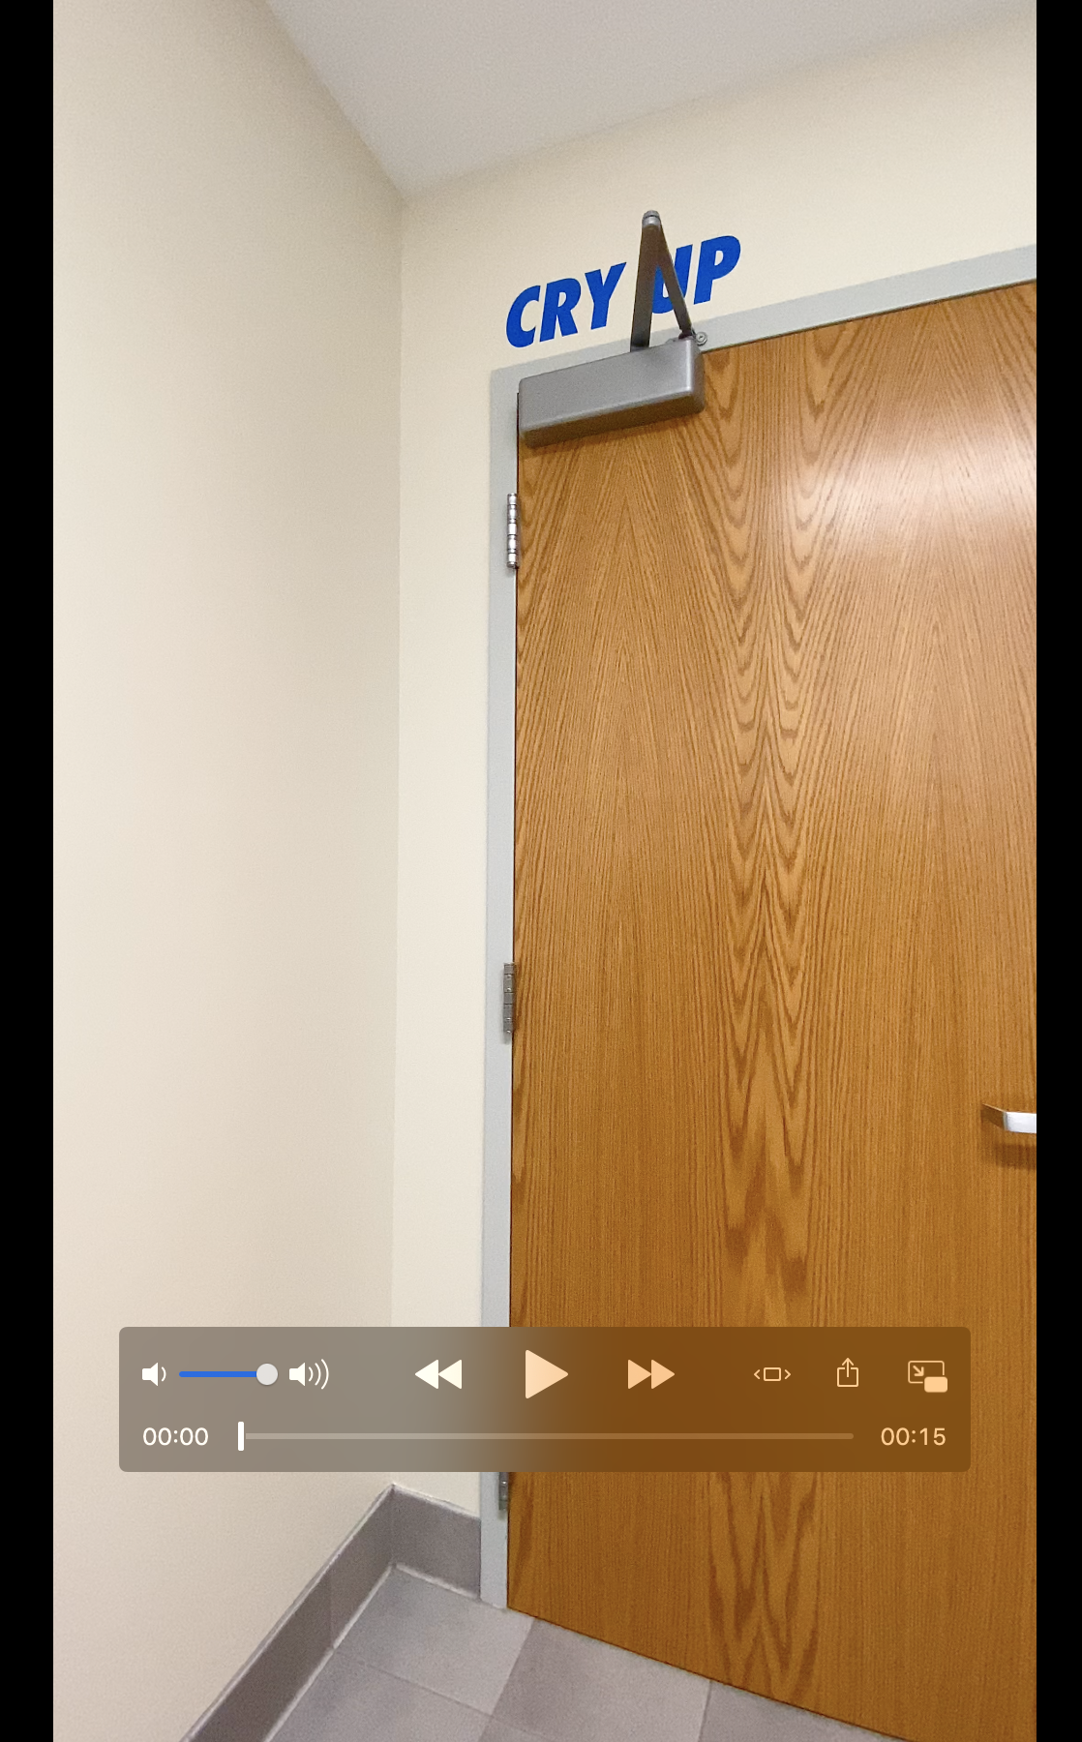  CryingBathroom_Tomlinson_8 | CRYING BATHROOM (VIDEO)  This installation is currently on view in the single use bathroom on the 3rd floor of Woods. This is one of a series of crying themed installations scattered around Lincoln and Arkansas. The locations reflect the spots I most frequently cry, and are meant to provide a sense of community and affirmation to my fellow cryers. Using humor and site-specific references I am attempting to normalize and make space for an act that we often do alone.
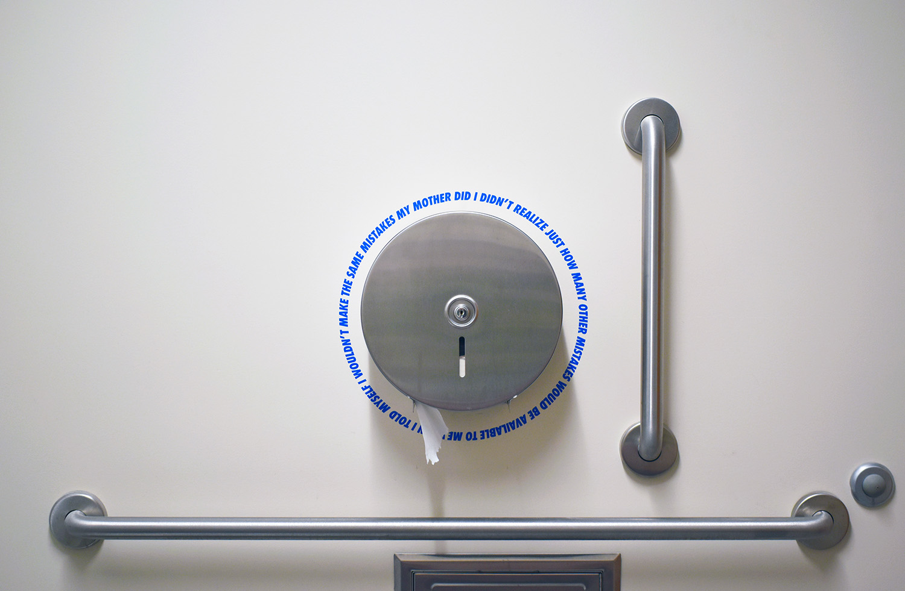  CryingBathroomDetail_Tomlinson_9 | CRYING BATHROOM (DETAIL)  The crying installations always respond to the architectural features of the space, and incorporate a mix of straight-forward and poetic language. Seen here is a detail shot of more poetic text that reads “When I told myself I wouldn’t make the same mistakes my mother did I didn’t realize just how many other mistakes would be available to me.”
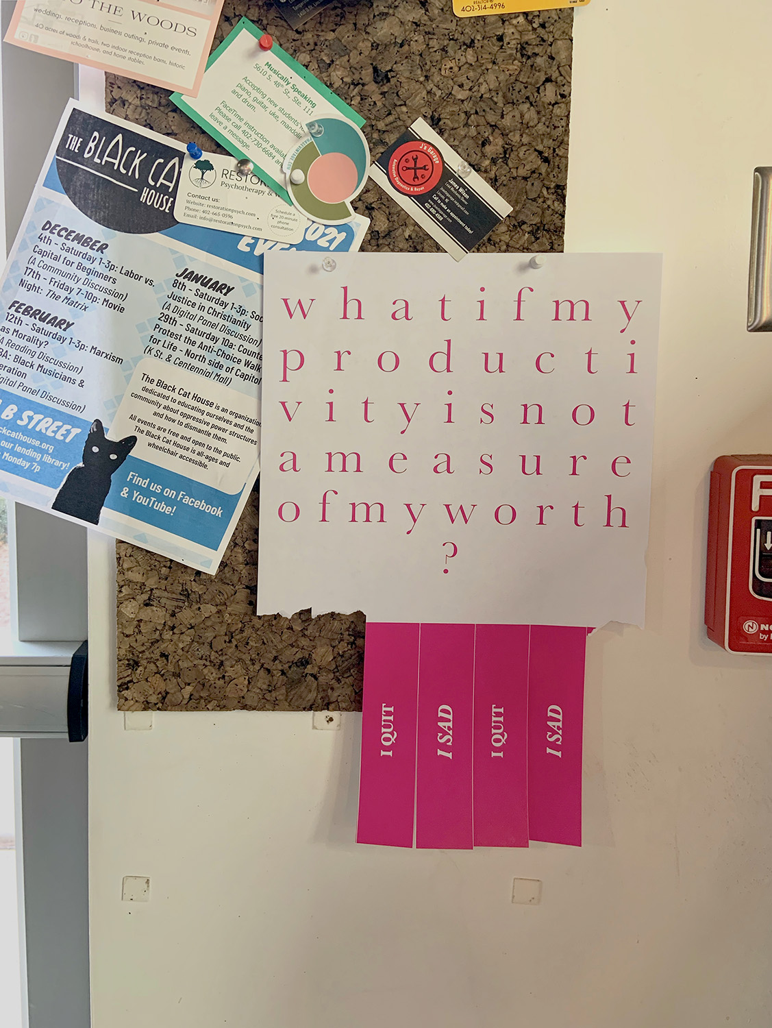  PullTabincontext_Tomlinson_10 | I QUIT I SAD (INSTALLED AT COFFEE SHOP)  This print is part of a series of pull tab flyers installed throughout places I frequent in Lincoln. The series addresses productivity and acts as a permission giver to reevaluate our relationship to work culture and challenges the idea that our identity is tied to our work. The flyers appropriate vernacular graphic forms to prompt discussion and reflection and highlight the discontent and anxiety of everyday work life. The phrases on the flyers vary, but the tabs all read “I QUIT,” and “I SAD.”
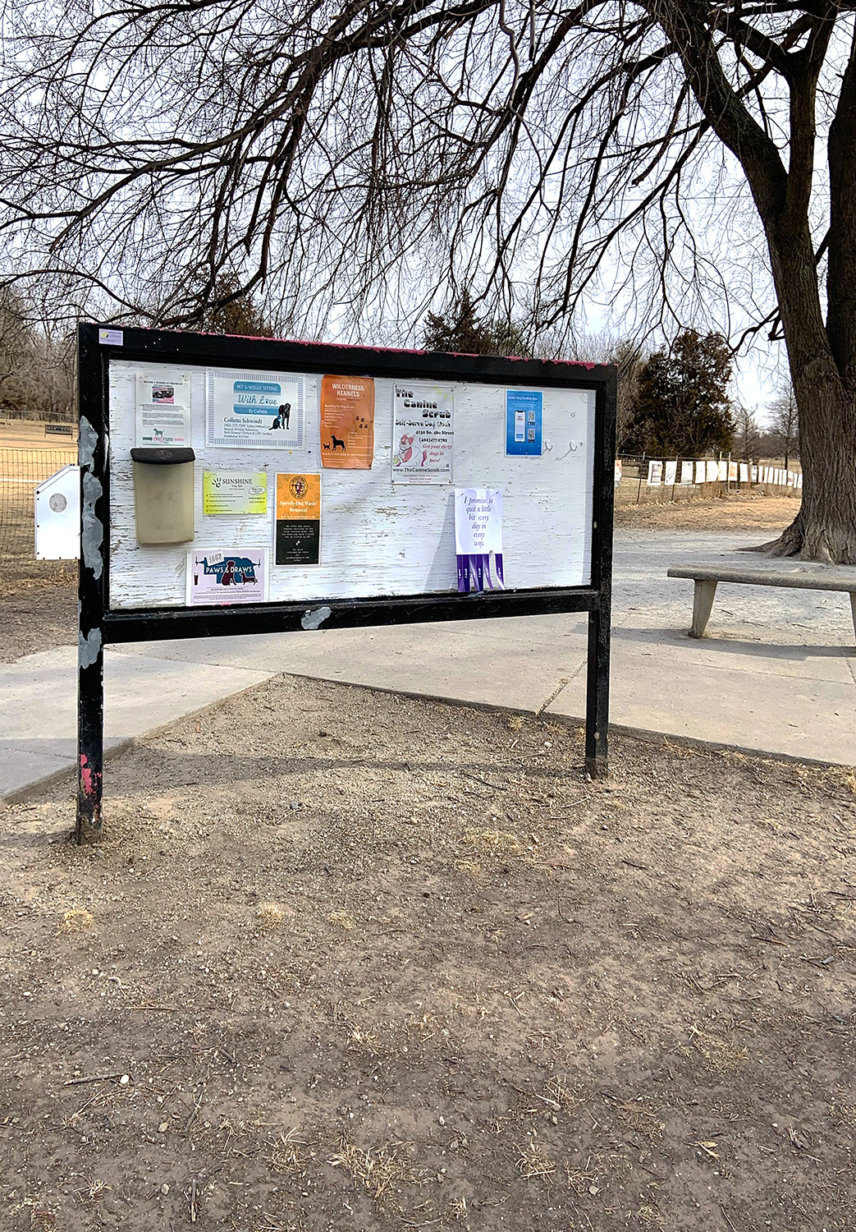  PullTabincontext_Tomlinson_11 | I QUIT I SAD (INSTALLED AT DOG PARK)  Pictured here is another “I Quit I Sad” in context.

